Skills Hub

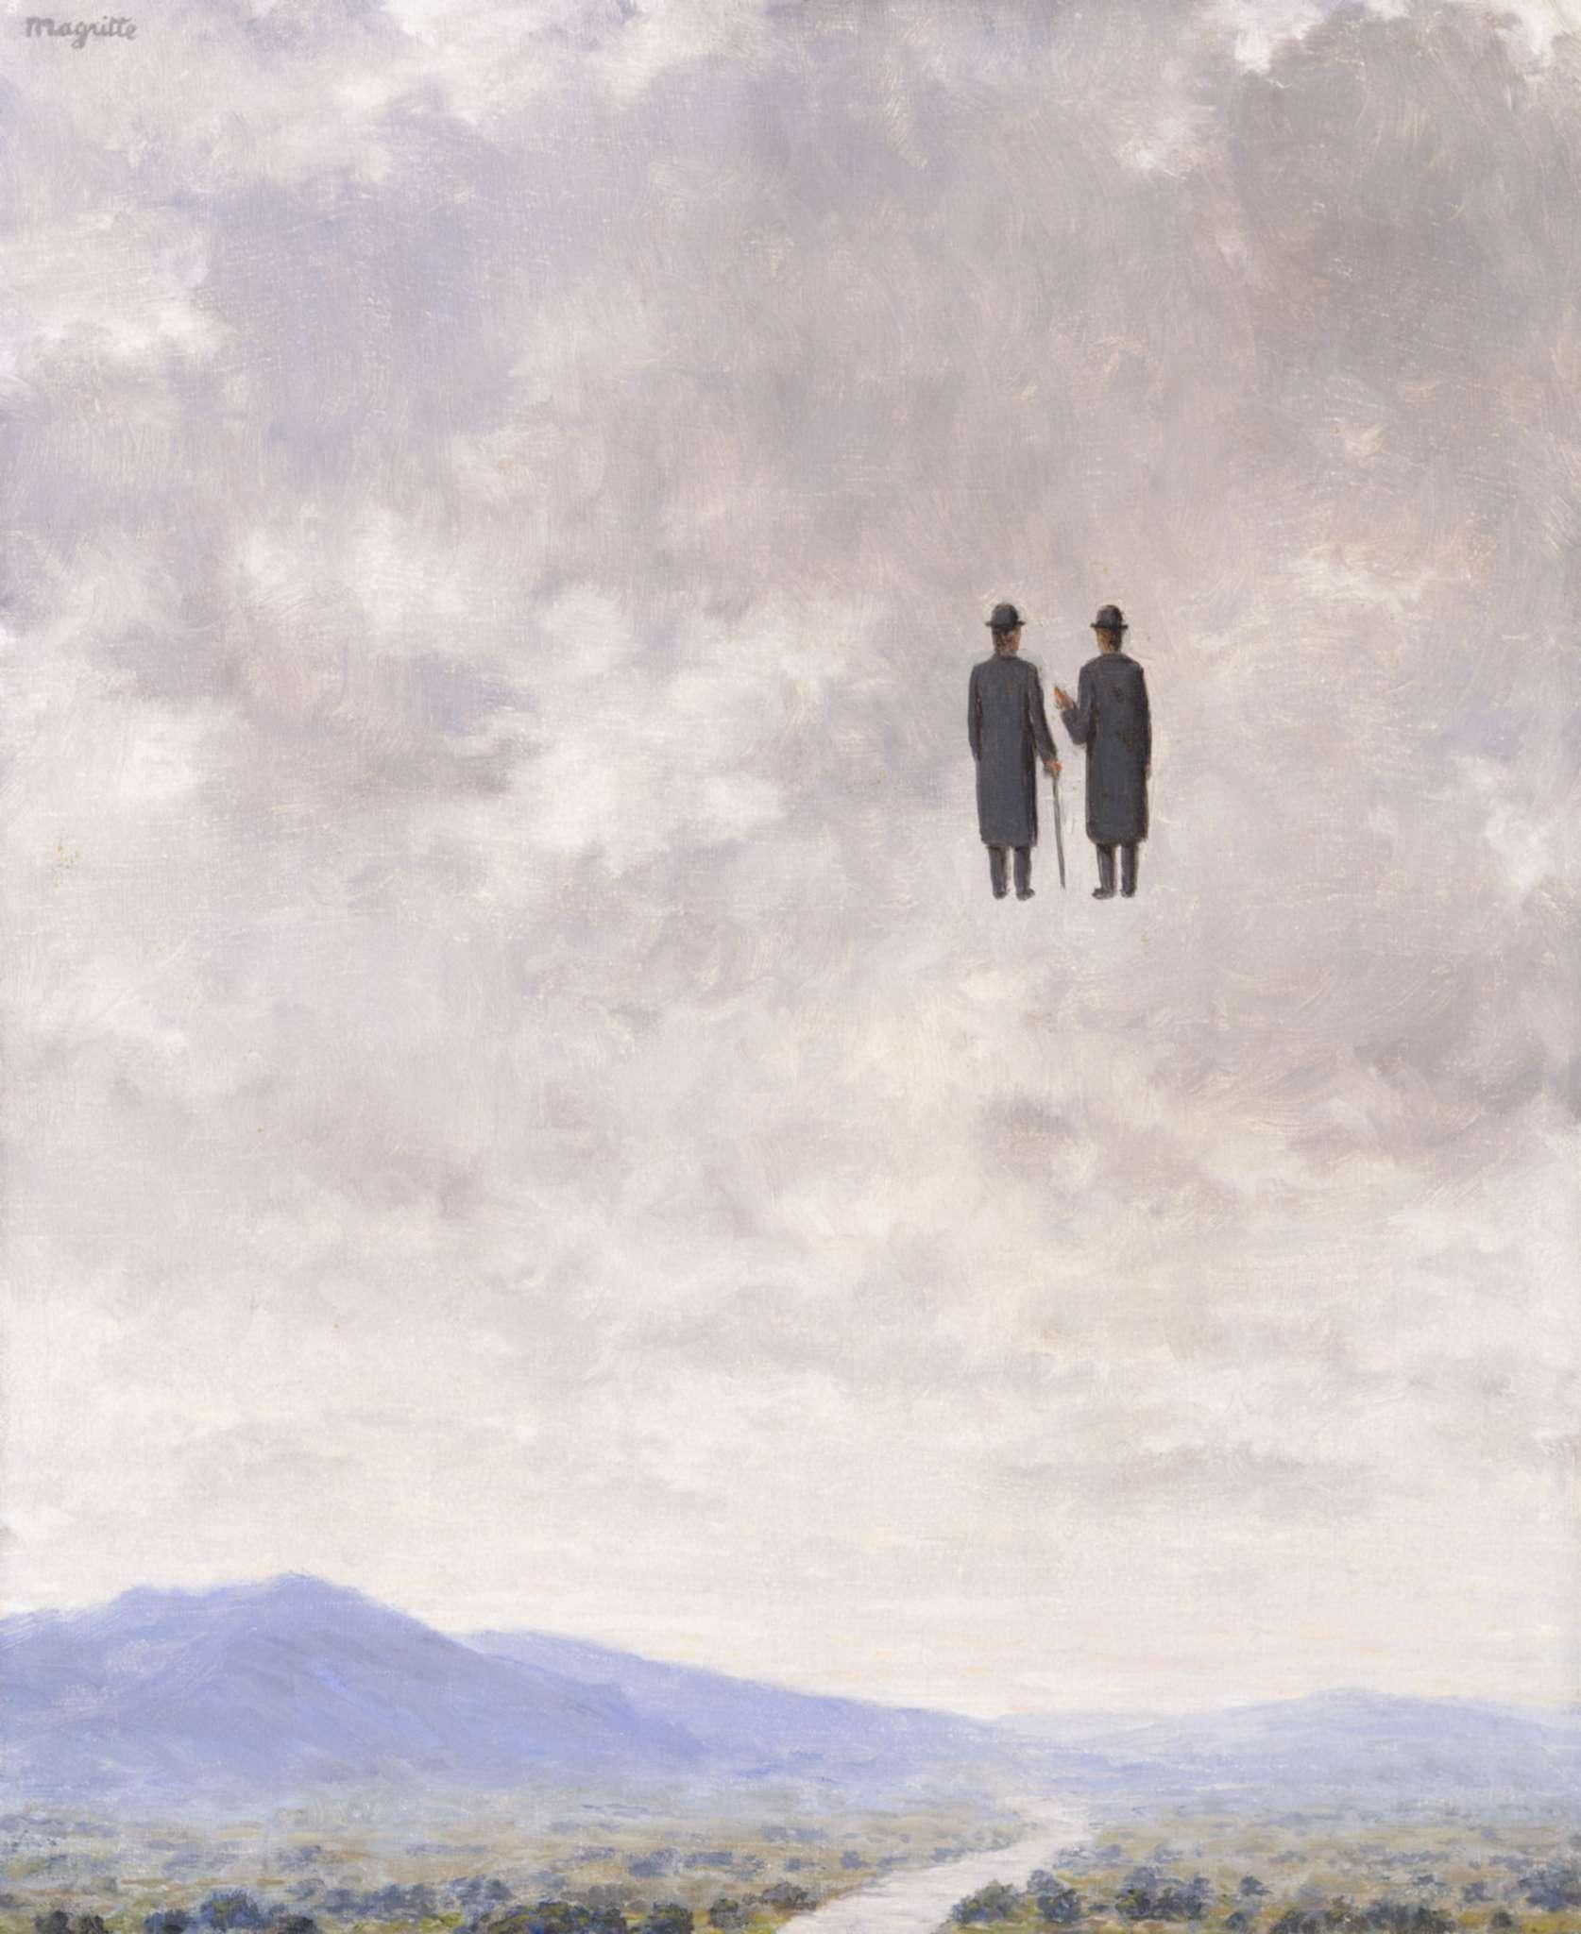
Understanding Poetic Voice
Magritte Rene, The Art of Conversation, c.1963 (oil on canvas) Image courtesy of Bridgeman Images.

Overview
The Understanding Poetic Voice micro course provides a guide to some different ways in which poets use voice in their writing and gives you the opportunity to experiment with some of these voices through a series of exercises. We will explore narrative voices, lyric poems, the speaker in the poem and the way in which they speak to the reader.

Context
Think of a poet you like, whose work you know and have enjoyed – how would you define their voice? Is it witty or philosophical? Does it convey emotions and make you feel something? If you picked up a poem and read it, without being given the poet’s name, how would you know they’d written it?
It’s often said that a poet starting out needs to ‘find their voice’, but what does this really mean? More than just theme or subject matter, a poet’s voice can be the connecting thread between the poems they write; it is the unique way a particular poet ‘speaks’ to the reader, or speaks what they have to say to the world. Voice isn’t necessarily about what a poet says, but how they choose to say it.

Materials Needed
You will need something to write with, and something to write on. A computer or tablet is fine, as is paper and pen or pencil. Adapt your writing materials to best suit your own needs.
If you are accustomed to using a blog / online learning log, these are also ideal places for you to keep notes and save your drafts.
It is also helpful to read poems, outside the course itself, and think about their voices. If you’re not able to buy a lot of poetry books, I’d recommend The Poetry Archive and The Poetry Foundation websites, which both have a huge back catalogue of poems available to read online.

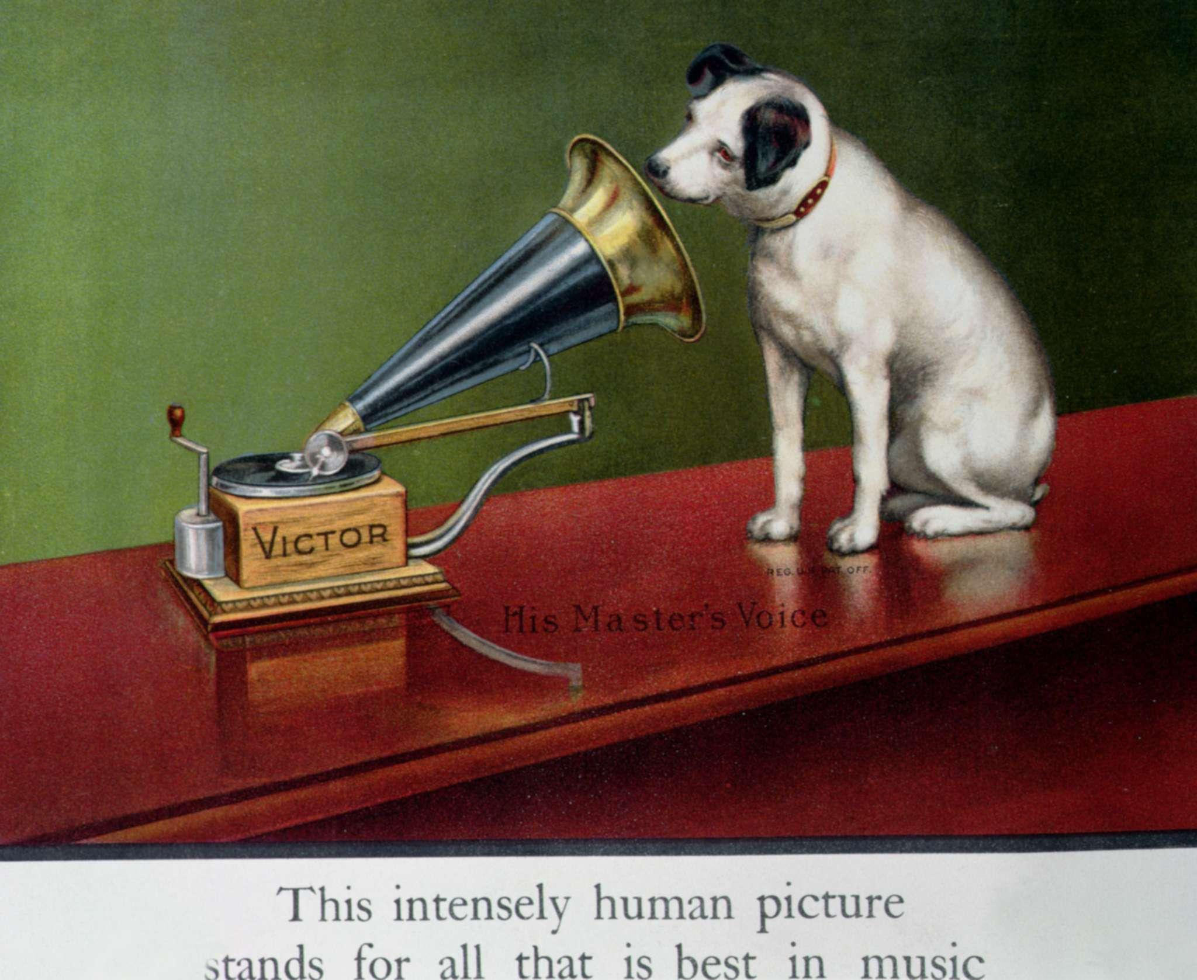
Poets on Voice
Francis Barraud, Advertisement for Victor gramophones, from 'The Theatre', c.1910 (colour litho) (detail of 189520) Image courtesy of Bridgeman Images.
Read the quotation below, in which the American poet Tony Hoagland talks about the difficulty of defining what poetic voice is:
“One of the most difficult to define elements in poetry is voice, the distinctive linguistic presentation of an individual speaker. In many poems voice is the mysterious atmosphere that makes it memorable, that holds it together and aloft [...] when we hear a distinctive voice in a poem, our full attention is aroused and engaged, because we suspect that here, now, at last, we may learn how someone else does it – that is, how they live, breathe, think, feel and talk.”
Hoagland (2019) The Art of Voice. Pg.1.
And here’s Amiri Baraka, who describes a poet’s voice as the place they start from, the thing they need to start writing before they learn anything else about the craft of poetry, and also the thing they end up with, in their writing, which makes their poems sound like theirs:
“The only ‘recognisable tradition’ a poet need follow is himself… & with that, say, all those things out of tradition he can use, adapt, work over, into something for himself. To broaden his own voice with. (You have to start and finish there...your own voice...how you sound.)”
Amiri Baraka, How You Sound in Herbert W.N and Hollis, Matthew,
Strong Words, Ed. (2000).
Do you think there is a noticeable ‘voice’ in your own writing? When you read your work aloud, does it sound like you, or like someone else? Is your poetic voice the same as your speaking voice? There’s no right or wrong answer, but this chapter will help you to understand different uses and styles of poetic voice, and encourage you to try some of them out in your own way, to see whether they suit your writing.

Who is Speaking?
Sometimes when you read a poem, it can be tempting to assume that the voice the poem is written in is that of the poet themselves, particularly if the poem has a lot of emotional content. However, this can be dangerous for the reader; it can lead you towards interpreting the poem’s events as factual truth, rather than thinking about the effect and making of the poem itself. What if the poem is actually a dramatic monologue in the voice of a parking metre? The American poet Kim Addonizio, whose poems often appear to be confessional in style and content, has this to say on the subject:

“The ‘I’ on the page might be analytical in one poem and over-the -top emotional in another. The writer might be a slightly better – or worse– person in daily life. And he or she might be inventing everything, pretending sincerity. Does this mean that poets can’t be trusted? In a sense, yes, if you read poems for facts. But poets do try to be true to life’s mystery and complexity, and in order to do that, they – and you, if you want to be truthful – need to invent.”
Kim Addonizio (2009) Ordinary Genius. P.128.

Narrative Voice
When poems use a narrative voice, for the most part, they are trying to tell us a story. The narrative voice often sounds quite like a spoken voice, like someone beckoning you in, and telling you a story. Tony Hoagland, in his book The Art of Voice says:
“Many gurus on the craft of writing declare that a writer should “make every word count”. Yet in poetry, often the charm of voice is more important than economy. After all, most of our daily exchanges don’t convey information in an economical manner. When we say “What’s up?” Or “Looks like rain,” our speech isn’t really about conveying information, but about signalling to the listener that someone is present and accessible – open to conversation.”
Tony Hoagland (2019 ) P.19.

Exercise 1: Listening
You’ll already have been told this I’m sure, but eavesdropping can be an absolute gold mine for a writer’s imagination. How often have you overheard something on the bus, or in the dentist’s waiting room, and let your mind wander? For this exercise, do exactly that, but on purpose. Do it next time you’re in a good position to eavesdrop.
Make notes if you need to, on your phone or on a scrap of paper, then use one of the things you’ve overheard as your writing prompt, and keep free-writing in your chosen voice. Don’t think too much about it being a poem, just let the voice of the person take shape on the page (you can always edit it later).
Once you’ve written enough, read over your piece again and have a think about the kind of person that you’ve written about. How do they speak? Do they talk in figures of speech or are they fairly plainly spoken? Do they speak quickly? Do they feel (as Tony Hoagland says) accessible and open to conversation?
Keep this in your notebook, or on your computer, or learning log and see if you can develop a poem from it.

Telling Stories
The way poems tell stories usually has to be quite contained compared to longer forms, because the form on the page can only contain so much information. But a few common pieces of advice do apply - don’t worry about moving your character from room to room, for example, if it’s just taking up time and space in your poem – just put them in the room where you need them to be.

Reading Task 1: The Fishing Pole of the Drowned Man
Read the poem The Fishing Pole of the Drowned Man by Raymond Carver (who also wrote many short stories):
The Fishing Pole of the Drowned Man
I didn’t want to use it at first.
Then I thought, no, it would
give up secrets and bring me luck —
that’s what I needed then.
Besides, he’d left it behind for me
to use when he went swimming that time.
Shortly afterwards, I met two women.
One of them loved opera and the other
was a drunk who’d done time
in jail. I took up with one
and began to drink and fight a lot.
The way this woman could sing and carry on!
We went straight to the bottom.
Raymond Carver, The Fishing Pole of the Drowned Man in All of Us (2003) P.88.
This poem mentions a lot of events, but many of them take part outside of the poem itself – including the death of the man in the title. Make a list of all the events and you’ll see there’s almost one per line. It’s a poem that tells a story with very few lines.
Think about the voice of the person telling the story. What kind of a person are they?

Exercise 2: Telling a Story
In your notebook (or on screen if you prefer), try writing a poem in this style.
Make sure the poem tells a story or anecdote (although some of the events can already have happened, or be foreshadowed by the poem). Give yourself 14 lines to do this, like Raymond Carver has used - no more!
Reflect in your writing diary on the challenges of telling a story in this concise form.

The World’s Wife
Carol Ann Duffy’s book The World’s Wife is full of poems that give the ‘other side of the story’ – funny but often poignant takes on popular myths and famous men, designed to give some space to the women in their lives.
Mrs Midas
It was late September. I’d just poured a glass of wine, begun
to unwind, while the vegetables cooked. The kitchen
filled with the smell of itself, relaxed, its steamy breath
gently blanching the windows. So I opened one,
then with my fingers wiped the other’s glass like a brow.
He was standing under the pear tree snapping a twig.
Now the garden was long and the visibility poor, the way
the dark of the ground seems to drink the light of the sky,
but that twig in his hand was gold. And then he plucked
a pear from a branch. – we grew Fondante d’Automne –
and it sat in his palm, like a lightbulb. On.
I thought to myself, Is he putting fairy lights in the tree?
He came into the house. The doorknobs gleamed.
He drew the blinds. You know the mind; I thought of
the Field of the Cloth of Gold and of Miss Macready.
He sat in that chair like a king on a burnished throne.
The look on his face was strange, wild, vain. I said,
What in the name of God is going on? He started to laugh.
I served up the meal. For starters, corn on the cob.
Within seconds he was spitting out the teeth of the rich.
He toyed with his spoon, then mine, then with the knives, the forks.
He asked where was the wine. I poured with a shaking hand,
a fragrant, bone-dry white from Italy, then watched
as he picked up the glass, goblet, golden chalice, drank.
It was then that I started to scream. He sank to his knees.
After we’d both calmed down, I finished the wine
on my own, hearing him out. I made him sit
on the other side of the room and keep his hands to himself.
I locked the cat in the cellar. I moved the phone.
The toilet I didn’t mind. I couldn’t believe my ears:
how he’d had a wish. Look, we all have wishes; granted.
But who has wishes granted? Him. Do you know about gold?
It feeds no one; aurum, soft, untarnishable; slakes
no thirst. He tried to light a cigarette; I gazed, entranced,
as the blue flame played on its luteous stem. At least,
I said, you’ll be able to give up smoking for good.
Separate beds. In fact, I put a chair against my door,
near petrified. He was below, turning the spare room
into the tomb of Tutankhamun. You see, we were passionate then,
in those halcyon days; unwrapping each other, rapidly,
like presents, fast food. But now I feared his honeyed embrace,
the kiss that would turn my lips to a work of art.
And who, when it comes to the crunch, can live
with a heart of gold? That night, I dreamt I bore
his child, its perfect ore limbs, its little tongue
like a precious latch, its amber eyes
holding their pupils like flies. My dream milk
burned in my breasts. I woke to the streaming sun.
So he had to move out. We’d a caravan
in the wilds, in a glade of its own. I drove him up
under the cover of dark. He sat in the back.
And then I came home, the woman who married the fool
who wished for gold. At first, I visited, odd times,
parking the car a good way off, then walking.
You knew you were getting close. Golden trout
on the grass. One day, a hare hung from a larch,
a beautiful lemon mistake. And then his footprints,
glistening next to the river’s path. He was thin,
delirious; hearing, he said, the music of Pan
from the woods. Listen. That was the last straw.
What gets me now is not the idiocy or greed
but lack of thought for me. Pure selfishness. I sold
the contents of the house and came down here.
I think of him in certain lights, dawn, late afternoon,
and once a bowl of apples stopped me dead. I miss most,
even now, his hands, his warm hands on my skin, his touch.
Carol Ann Duffy, Mrs Midas in The World's Wife (1999) London: Picador.

Exercise 3: Many Sides of the Story
Take two or three different characters who are involved in the same story or narrative and write in their voices. This means you might have three different parts of the narrative told chronologically, or you might have the same incident told in three different voices emphasising different aspects of the same event. You might choose a topic like:
A broken ornament -
- Voice 1: The mother’s viewpoint.
- Voice 2: The child who broke the ornament
- Voice 3: The sibling who saw it all
Or you might take the same character at different points in their life showing how their attitude to one of their possessions has changed. Work on this piece in your notebook, or on your computer.

Lyric Poems
As you might guess from the name, lyric poetry was originally a form that was accompanied by music. When we talk about lyric poems, we tend to mean a poem written often (but perhaps not exclusively) in the first person with a focus on the personal, that communicates a mood, a moment, or a feeling. It generally places less focus on ‘what happened’ than a narrative poem might do.

The Lyric ‘I’
When poets talk about the lyric I, they generally mean that first person voice of the lyric poem. Sometimes the ‘I’ of the poem is the same as, or very similar to, the poet – but it’s best not to assume things about the poet, or base judgements upon the I, so it’s best always to refer to the I as the speaker of the poem, rather than the poet themselves (just like we heard from Kim Addonizio a few pages back).

Here is a lyric poem by the British poet Mona Arshi:
The Rain That Began Elsewhere
I traced a stitch raised by your absence.
I concentrated on this panel of sky
and wound myself into a ribbon of silence.
I have sat at the brink drafting a lie.
I have held my breath, entered the rooms,
drawn down the blinds and opened my eyes.
I’ve stood still enough to find my own way home.
I died a little when I took tiny sips of Spring
and spared no thought for when it had gone.
I know all I need to know. I breathe in
the shadow’s scent when it is near
and commit it to my own silent skin.
I rest on the tilted fence to prepare
For rain, the rain that began elsewhere.
Mona Arshi, The Rain that Began Elsewhere in Small Hands (2015) Liverpool: Pavilion Press/LUP.
This poem is one full of grief, which is realised in beautiful delicate images that allow us to visualise the speaker’s experience. The poem also has quite a strict rhyme scheme which allows the reader to slow down and experience each image. Sometimes writing about a feeling can feel very large, abstract and formless and a formal constraint like this can help the poet exercise control over their subject. You’ll also notice the use of concrete details in this poem (’a panel of sky’, the blinds, the rain) rather than abstract nouns (things you can’t see - grief, sadness, anger, for example). This has the effect of focusing the reader’s attention on the poem itself, rather than sending them into their own experience of these abstract things.

Research Task 2: Lyric Poems
Find at least two more lyric poems.
What makes them lyric poems, do you think? What feelings do they communicate?

Exercise 4: A Lyric Moment
Think of a past emotional experience, positive or negative. It will help if the experience feels distant to you now, or you feel you’ve processed it, because you’ll be able to imagine it from the reader’s / an outsider’s point of view more easily than if you were in the thick of it. Also, writing about emotional experiences is best approached with caution, so please make sure you feel safe with the subject you’re writing about, and stop and go on to the next exercise if you don’t.
- Make some notes about how you felt (you don’t have to mention any event, necessarily, just as in the poem above).
- Think of some details you can remember about something quite mundane from the time (usually life is going on in the background). It could be the street you lived on, the things you saw everyday, mundane tasks you remember doing around the house, for example.
- Write out these things in a list - decide whether you’d prefer to use past or present tense, for example:
I felt like I was waiting.
I looked at the flowers in other people’s gardens.
I woke up at seven in the morning and listened to my neighbours leaving for work in their cars.
Once you’ve finished your list, read it aloud to yourself. Does any of it work as a poem? Does it feel lyrical? Does it communicate your feelings to the reader? Look back at your narrative writing exercises. How do these poems feel different?

Who are You Speaking To?
Read the poem A Man is Dragging a Dead Dog by Jack Underwood (content warning: animal cruelty):
A Man is Dragging a Dead Dog
on a lead, down the street.
It makes a low-register hissing sound that is constant and gives you a sense
of the weight of the dead dog. The lead is pulled tight to a straight line.
It is attached to a collar which is the point of the freight most forward,
the dog’s head having been pinned beneath its body as it moves along relatively
slowly against the pavement making that hissing sound. The rearmost point
of the dead dog is what you might call, in this instance, its “bottom leg”
because the pelvis has been rotated, the dog twisted on its side, so one leg
is in full contact with the ground while the other is slightly elevated and wobbles.
And since you already have a street in mind and perhaps a breed of dog,
a colour of lead, or the kind of coat the man is wearing, why not become
the man dragging a dead dog on a lead behind you? Why not try
to understand this thing you are doing: how the dog came to be dead
and you came to be dragging it, what this means to you and where is it
that you are going?
Underwood, Jack (2016) Happiness. London: Faber & Faber.
This poem works because of the way it addresses the reader; figuratively turning on them in the second half. Its first stanza does the work of making the reader see something, and the second half almost makes us feel complicit in the poem because of our act of imagining, which causes a great deal of discomfort to the reader. As a poet, Jack Underwood seems to be very interested in how the poet can manipulate the reader, using their words to get the reader to think about things / imagine things they might not want to, and to make the act of reading the poem into ‘this thing you are doing’ – this is a prime example of that.

Exercise 5: Addressing the Reader
You’re going to write a poem that addresses the reader. You don’t have to manipulate them in quite the same way that Jack Underwood’s poem does, but you can if you like.
Pick one of the following starting points, and start to write as if you are addressing someone:
- Directions to a particular location.
- A recipe for making something.
- Instructions for a procedure.

Dramatic Voice
Dramatic voice, as you might guess, has something in common with theatre, and you can often imagine a poem written in dramatic voice being read aloud on stage.
This is a poem you may already know, by the American poet and human rights activist Carolyn Forché, which uses dramatic voice (content warning: physical violence).
The Colonel
What you have heard is true. I was in his house. His wife carried
a tray of coffee and sugar. His daughter filed her nails, his son went
out for the night. There were daily papers, pet dogs, a pistol on the
cushion beside him. The moon swung bare on its black cord over
the house. On the television was a cop show. It was in English.
Broken bottles were embedded in the walls around the house to
scoop the kneecaps from a man's legs or cut his hands to lace. On
the windows there were gratings like those in liquor stores. We had
dinner, rack of lamb, good wine, a gold bell was on the table for
calling the maid. The maid brought green mangoes, salt, a type of
bread. I was asked how I enjoyed the country. There was a brief
commercial in Spanish. His wife took everything away. There was
some talk then of how difficult it had become to govern. The parrot
said hello on the terrace. The colonel told it to shut up, and pushed
himself from the table. My friend said to me with his eyes: say
nothing. The colonel returned with a sack used to bring groceries
home. He spilled many human ears on the table. They were like
dried peach halves. There is no other way to say this. He took one
of them in his hands, shook it in our faces, dropped it into a water
glass. It came alive there. I am tired of fooling around he said. As
for the rights of anyone, tell your people they can go fuck them-
selves. He swept the ears to the floor with his arm and held the last
of his wine in the air. Something for your poetry, no? he said. Some
of the ears on the floor caught this scrap of his voice. Some of the
ears on the floor were pressed to the ground.
Carolyn Forché, The Colonel (1978) in The Country Between Us (1981) Harper Collins.
Carolyn Forché has worked in many countries in the world and has written about the poetry of witnessing, so the events of this story may be true, but this poem has the feel of something that could be read as dramatic monologue, a speech by a single character or persona.

Exercise 6: Choosing a Voice
For this exercise, you need to choose a voice other than your own to write with. Perhaps looking at images might help you to pick a character – you could use the Bridgeman Education Image Library to find someone who you think you can speak for.
Once you’ve got your person in mind, think about how they might speak, what might interest them, what their concerns are. How is their voice as a speaker going to be different from your own voice? You could have them talk about something that happened to them, like in The Colonel, or you could start them out talking about something fairly everyday and see what they come up with.

Dialect and Poetry
Dialect is in itself a voice that many poets use; stepping away from the more classical and canonical, and using ‘their own’ voices, voices that speak from a place and a particular way of life. Dialect can be used to great effect in poems, and seems to be increasingly of interest to contemporary poets.
Liz Berry is a Black Country poet who uses dialect in her poems. She has some useful advice in an article for the Poetry School, Using Dialect in Poetry, where she recommends you read widely so that you are at home in whatever dialect you want to use and that you listen on Youtube.
Here is her poem, Birmingham Roller which includes some Black Country words and expressions.
Birmingham Roller
“We spent our lives down in the blackness… those birds brought us up to the light.” (Jim Showell – Tumbling Pigeons and the Black Country)
Wench, yowm the colour of ower town:
concrete, steel, oily rainbow of the cut.
Ower streets am in yer wings,
ower factory chimdeys plumes on yer chest,
yer heart’s the china ower owd girls dust
in their tranklement cabinets.
Bred to dazzlin in backyards by men
whose onds grew soft as feathers
just to touch you, cradle you from egg
through each jeth-defying tumble.
Little acrobat of the terraces,
we’m winged when we gaze at you
jimmucking the breeze, somersaulting through
the white breathed prayer of January
and rolling back up like a babby’s yo-yo
caught by the open donny of the clouds.
Black Country / Standard
yowm / you are
cut / canal
tranklement / bits & bobs or ornaments
onds / hands
jeth / death
jimmucking / shaking
babby / little child
donny / hand
Liz Berry (2015) Black Country. London, Chatto & Windus.
Sometimes it can also be helpful to listen to a poet reading their work aloud in their dialects or local languages. You can listen to Liz Berry reading another poem, Bobowler, on BBC Arts.
Some more dialect poets to look up are:
- Anna Robinson (East London)
- Ian McMillan (South Yorkshire)
- Harry Josephine Giles (Orcadian)
- Kei Miller (Jamaican Patois).

Exercise 7: Speak in Your Own Voice
Are there any words from your own part of the world that you would like to use in a poem? A dialect is generally regional, but some of us even have words and expressions that belong to a smaller group than that, such as immediate family.
Make a list of words that belong to your place, or your people. See if you can use some of them in a poem.
Make drafts in your notebook, or on a screen if you work better that way.

Other Voices
Sometimes a poet can use their writing power to give voice to something that we might not already hear, be that an animal, a plant, a landscape or an inanimate object. Here are two examples:
Glacier Song (Extract)
At 4am, the Knud Rasmussen glacier
does breathing exercises. In
then out.
It holds a note of silence
in its million, cool blue throats
and keeps it, lozenge made of cold.
It wants to sing its own labyrinth
its library of absences
its fins and hundred entry points
but it’s not yet dawn
and the fjord is flat-backed, grey
and barely listening
and, besides, the fjord wants to sing too,
or chant the things it knows of ice.
It wants to say:
A glacier underlines the earth.
A glacier is all-night gunfire, frozen fireworks.
A glacier is nothing like a hearth.
A glacier is a body and its nurse.
A glacier is all the things it was
and all the things it will be yet.
A glacier is a misplaced bet.
It wants to say I am a glacier too
but as the light folds in over the northern peaks
it won’t say anything, the way
the mountains it reflects
hold quiet inside them
like new music strange cathedrals
made of stone
and will not sing
about the way they’re lit at sunset,
whole in late August
so the tips of them are bright as pokers,
glowing coals
won’t sing
about collapsing ridges
and their human trespassers,
balancing,
stern with the ballet of scree-hopping.
They are just mountains
with their private stock of images -
white cotton flowing
from a summit framed by sun,
a halo
or a snowglobe shaken hard
Helen Mort, from The Singing Glacier (2018) London: Hercules Editions.

You and Your Fridge
To your fridge, you are an idiot God
stashing your milk in its cold gut. Your phone
shares your secrets with the toaster,
which scorches the face of your ex onto your bagel
to see if you are paying attention.
Your car comes complete with its own joke. It says
I don’t need you anymore. It’s true –
you’re a legacy organism – but also a consumer
which means your files will be kept
for a long time. On your phone it says
that even after your death they may be conscious
You blink. The models which describe your behaviour
may be conscious. They will also be
company property. This is not good news.
You stop reading the article. The fridge asks
whether it is conscious. You say: Maybe,
I don’t know. Do you feel conscious?
You blink again, decide what is and isn’t real
then you breathe out, like it really means something.
The fridge is silent, perfect, angry, scared.
Tom Sastry, A Man’s House Catches Fire (2019) Rugby, Nine Arches Press.

Exercise 8: 9 New Voices
Both these writers, in very different ways, give voice to something we wouldn’t normally hear speak. For your writing exercise, think of something you’d like to give a voice to. It could be a pet, or a plant, or a pigeon on the high street. It could be as big as the moon or as small as a chromosome. It could be a piece of machinery.
- What does it think of humans, and how does it interact with us, if at all?
- Does it have anything it would like to tell us?
- How does it see the world around it?
- What are its obsessions?
- What is its voice like? Does it use standard sentences and spelling?

Exercise 9: Reflection
In this Skills Hub course you have explored the use of voice in poetry; from the narrative voice to the lyric, through speaking / writing with our own voices, and all the ways in which a poem can speak to a reader.
Reflect on your learning from this short course, and what you have learned.
Are there any pieces of writing that you’re pleased with, or any that you want to continue working on? Do you think what you have learned here will be useful in other parts of your studies? How important do you think the use of voice is to you as a writer?
It may help you to write or record a video commentary (approx 300 words or 2 min video) reflecting on your learning here and how this connects to broader themes in your work or ideas - what have you learnt about Understanding Poetic Voice so far? What do you find particularly engaging? Reflect on the skills you have acquired here and how you might apply them to your developing creative practice.

Supporting your skills
As you create work that responds to the exercises on this micro-course, you may want to ask questions from tutors or share your work with your peers to support your studies here. Please use the support spaces in the Skills Hub to receive specialist support responding to the specific skills you're developing.
When you are ready to apply the skills you have acquired here, please return to your creative department and unit that you're undertaking.

About the Skills Hub
The Skills Hub offers learning opportunities across a range of disciplines to help you develop your creative skills. If you would like to offer any feedback or make suggestions please use the Skills Hub forums on OCA Learn.
We hope you have found this resource useful. Sharing your experiences with fellow students can help inspire and motivate others, please use the online spaces to support each other.

