Skills Hub

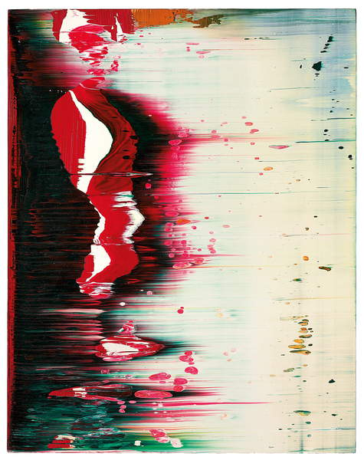
Painting with Colour
Richter, Gerhard, Fuji, 1996 (oil on alucobond) Image courtesy of Bridgeman Images.

Overview
The Painting with Colour resource explores a wide range of methods for applying, mixing and experimenting with coloured medium. The following exercises and research points support both technical and creative skills, building knowledge and understanding of handling paint. You will encounter various painting mediums, such as acrylic, oils, gouache and learn to control and manipulate paint in response to realist subjects and abstract approaches.
The tools and surfaces used when painting can also make a difference to how colour adheres and reflects light, creating a multitude of possibilities to be creative and expressive. You are encouraged to follow the fluid nature of paint and focus on the process of discovery, using this resource as a guide to begin your learning journey. The exercises allow you creative licence to choose the scale, materials and tools you use, as well as the types of subject matter you may work with. Whilst the resource is linear in nature, you may find it appropriate to work on exercises concurrently as your brushes are wet and you find yourself in the flow of painting and exploring with colour.
The course is divided into five exercises:
- Basic paint application
- Understanding colour
- Painting the colours you see
- Colour relationships
- Personal pallette
Depending on your prior knowledge and skill set, you may wish to mix and match these exercises and adapt the course content for your own learning needs.

Introduction to Painting
Painting can be defined as any activity that involves adhering pigment to a surface or ‘support’. The impulse to represent, to tell stories, to symbolise and to decorate by making images goes back to the very earliest period of human history.
“The earliest pigment use that we know of is from the lower Palaeolithic period, about 350,000 years ago.”
Kassia St.Clair, The Secret Lives of Colour (2018).
The sophisticated and stylised cave paintings of animals and human figures discovered in France were made by rubbing earth pigments onto the cave walls. The modern painter no longer has to make their own pigments. However, it’s worth developing a basic understanding of the properties of the many paints that are now available so that you can choose those that best suit your aims and developing methods. And while there are many tried and tested techniques for applying paint, it is only by experiment that you can really discover the exciting potential of different painting media.

Materials needed
The following exercises are not structured around individual materials, but rather ideas and techniques. You are encouraged to experiment with as many different drawing and painting materials as possible.
Below is an introductory list of material you may wish to use:
- Pencil – graphite, coloured.
- Crayon – wax, conté.
- Chalk, coloured pastel.
- Ink – coloured ink, permanent marker, felt tip pens, biros.
- Paint – oil, watercolour, gouache, acrylic, encaustic, tempera, fluorescent.
- Found materials – wax, polish, nail varnish, flour, salt, house paint, bleach.
- Printing – monotype, collagraph, lino, etching, digital.
- Surfaces – A3, A2, A1 cartridge paper, newsprint, newspaper, tissue, textiles, canvas, food packaging, hardboard, MDF.
- Tools - Brushes, various sizes, palette knives, sponges, bottles, squeegee.

Workspace
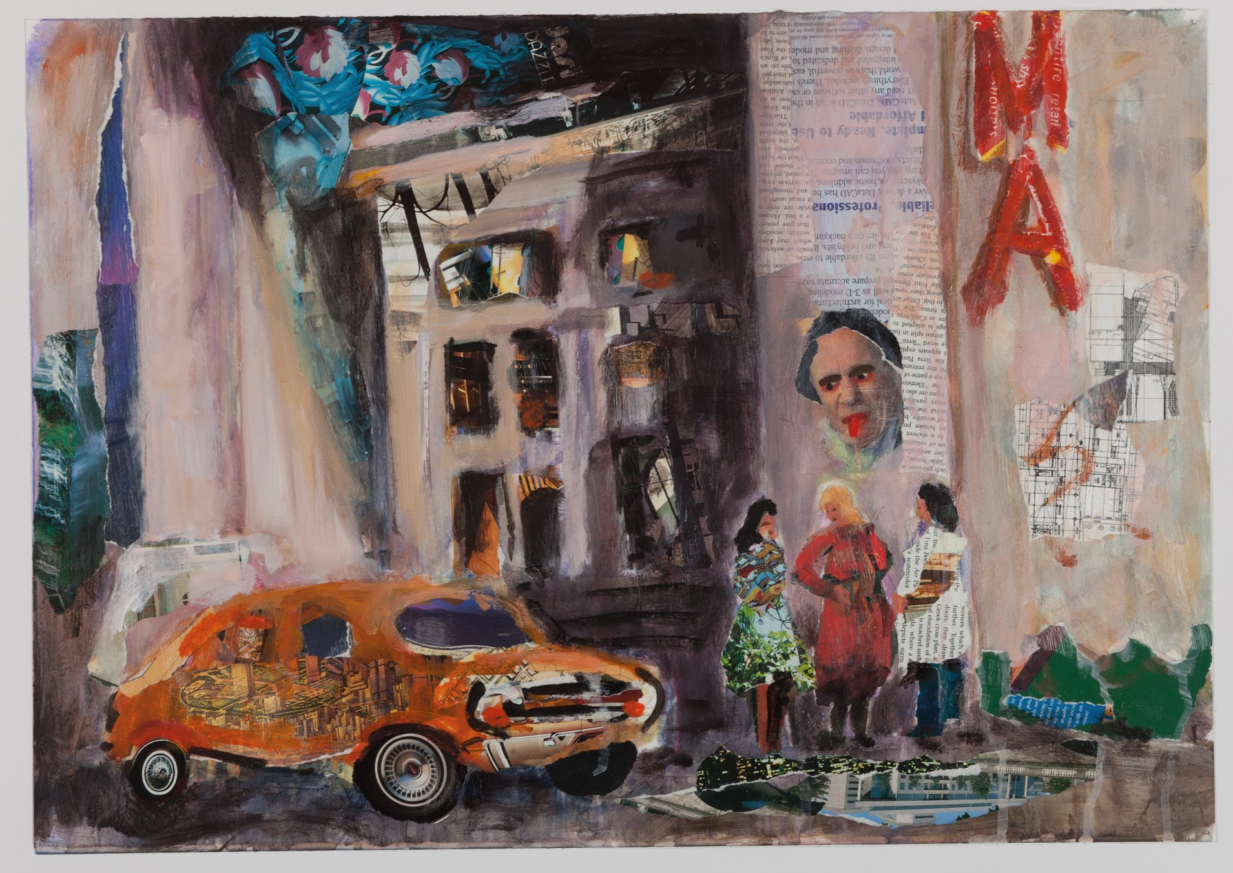
You will also need somewhere to work. As distance learners, OCA students have a wide range of studios – from a kitchen table to a purpose-built room or shed. Whatever you have, it is really helpful to ‘ring fence’ it for the duration of your studies. If you can’t lay claim to a table, then do lay claim to a nearby wall and pin-up your work so that you can see it easily, even when you are not actually studying. This really helps to keep the momentum going: having to unpack everything each time is off-putting and can result in you not making a start at all if you feel you’re short of time. Having everything around you will remind you of all you’ve achieved and help you keep ideas in mind to take forward to future exercises and assignments.
Peter Pateluch, Image courtesy of OCA student.

Sketchbooks
A sketchbook is a vital piece of kit for any painter. It can be used for observations, quick studies made on the move and noting down and developing your ideas. It is a record of a work in progress – your development as a painter.
Drawing from observation is a key skill that can only improve with practice. If you’re prepared to draw anything and everything you see, you’ll soon develop your observational skills and your ideas as a painter. You’ll also develop your repertoire of mark-making and understanding of colour mixing, colour consistency, and the various effects different painting tools can create.
Larger sketch pads and sheets of paper will allow you to develop your ideas in more detail and to try out different compositions and effects. You can simply divide a page into four or make four small boxes. You can then make comparisons between different formulations based on one idea or different compositional arrangements.
By keeping a record of your ideas – in effect, a visual diary – you’ll find out what really interests and intrigues you. How you use your sketchbook is up to you. You could include quite highly worked studies alongside very simple sketches. You could try out new colour combinations, drawing techniques or make written notes about what you see and which colours you may use later. You may just wish to jot down ideas. You could be developing ideas for a current project or noting down something you may develop in the future. This is a place for ideas and experiments, for trying out different materials and colours and noting down their effects.

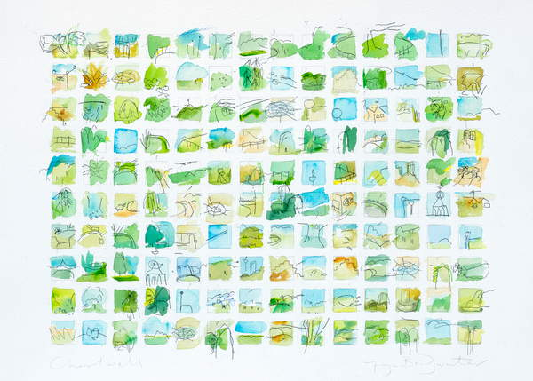
Faye Bridgwater, Chartwell, 2020 (w/c and ink on paper) Image courtesy of Bridgeman Images.

Which paint to use
Most paints, whether they are for artistic, domestic or industrial use, fall roughly within two categories based upon the medium that binds the pigment. Broadly speaking paints are either water- or oil-based. In addition to oil and acrylic paint, there is watercolour, gouache and tempera, all of which are widely used by artists today.
It’s good to experience a wide range of materials but buying in a basic range of colours, supports, mixing medium, diluents and varnishes can be an expensive business. For the exercises on this course, you can choose the materials and medium most suitable for you. A set of Acrylic paints will be enough to get started and in the future, you may wish to repeat exercises with a different medium.
Apart from the effects that you wish to produce, you’ll have to think about how and where you’re going to paint. If you have a spare room or even a garden shed or garage that can be lit and heated, then you could consider using oil paints. However, if you have limited space that you share with others, the fumes given off by oil paint and solvents may be unacceptable. Wherever you work, the volatile nature of oil and white spirits means that you must avoid naked flame around your materials.
Acrylic paints, on the other hand, are water-based with no volatile solvents associated with them. They can be used and cleared away quickly owing to their fast drying time so may be more practical to use in a busy household.

Pigments
Pigments have been used as colourants since prehistoric times. Early humans used pigment mixes to paint body decorations and the earliest known cave paintings dating back between 350,000 and 400,000 years ago, seen in a cave in Zambia where Ochre and iron oxide was noted as the first colour of paint.
Pigments are an effective way for creating your own colours and make a great addition to off the shelf mixed media paints. By mixing pigment powder with a binder, such as water or oil, you can create your own acrylic colour, oil colour, watercolour, pastels, acrylic ink and gouache in any shade you want. It’s a good value method of acquiring paints that exactly match the way you work. Benefits of using pigments include; they have an unlimited shelf life, they do not contain any preservatives or other additives, they are alkaline-resistant, authentic earth pigments contain no preservatives or additives.
A Colorful History of Paints and Pigments, by Google Arts and Culture

Acrylic paint
Acrylic paints were developed in the 1950s, and in the 1980s gained ascendancy over oil paint as a popular medium for artists. Acrylic is a versatile medium: it can be used in pale washes similarly to watercolour paint or it can be used alone or in conjunction with other materials to create highly textured effects.
Acrylic paints are made up of pigments suspended in acrylic polymer emulsion. They are water-soluble but when dry form into plasticised skin. New synthetic pigments have been developed and colours have improved steadily over the last 60 years. However, the massive range of pigments available to artists in both watercolour and oils is not yet available in acrylic.
The formula for acrylic paint has improved as technology has moved on. The paints don’t yellow with age and they form a permanent and strong surface layer. Because acrylic dries quickly, colours can be overlaid faster, and it combines readily with other materials. However, rapid drying means that you don’t have the luxury of being able to adapt and change your painting in the way that you can with oil paints. It is also harder to blend colours with the subtlety that is possible with oil paints.
You’ll need to wash your brushes quickly so that the rapidly drying paint doesn’t clog the ferrule of the brush. Synthetic hair brushes are better than expensive sable brushes as they’re much easier to clean and less prone to damage from dried paint. If paint does start to harden on the brush, soak it in warm water and washing-up liquid and ease out the softening paint. While mainly considered safe, acrylic paints are still chemical cocktails, releasing agents that are not entirely harmless. If you have safety concerns, consult the manufacturer’s label.
Water is the diluent for acrylic paint but a variety of mediums can be used to alter the flow and texture of the paint. Gloss or matte medium can be used to extend the paint into transparent glazes. Flow improver can be used so that acrylic paints can be thinned more easily. Gesso can be used to create textured surfaces or you can buy modelling or texture paste from artists’ suppliers. These are formulated especially for use with acrylic paints.

Colours
Any manual for artists will recommend a colour list and these vary greatly. Starter boxes are useful to buy and often come cheaper than buying paint separately. You can supplement the colours that you have when you have a clearer idea of the range of colours that you want to work with. It’s cheaper to buy larger tubes than small tubes and you’ll certainly need a large tube of white as this will be in continuous use.
Paint brands vary in their recipes; as you become more experienced, you’ll develop your own preferences in brand and colour. Artist quality paints are far more expensive but may go further than student quality paints which have less pigment and more fillers and other agents. Artist quality paints very often have pure pigments, which will make the colours brighter, stronger and more saturated. As your paint collection grows, keep a record of the colours and the manufacturers that suit you best.
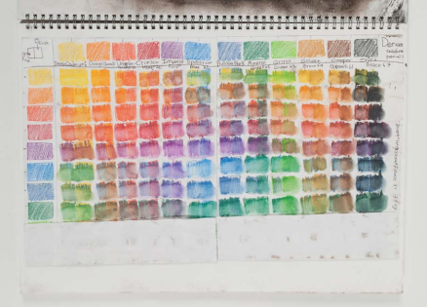
Acrylic paints come in tubes and bottles in a wide range of sizes and prices. Large tubes are better value so definitely go for large tubes or bottles of white paint. The following list of colours should give you a good start: Cadmium Yellow, Lemon Yellow, Cadmium Red, Alizarin Crimson, Violet or Purple, Ultramarine, Cerulean Blue, Prussian Blue, Yellow Ochre, Indian Red, Raw Umber, Burnt Umber, Sap Green, Viridian, black and white.

Anna Bernard, Image courtesy of OCA student.

Other types of paint

Watercolour
Many paints are water-based but watercolour is a particular paint medium developed for highly specialised uses and techniques. Watercolour paints are most often used in thin transparent washes through which the white ground can be seen. Some of the techniques of colour blending with superimposed washes or wet-in-wet blending have been adopted for use with oil and acrylic paints.
Watercolours have a special place in the development of landscape painting history as exemplified in the work of eighteenth/early nineteenth-century artists: John Sell Cotman, John Robert Cozens and JMW Turner. More recently artists such as Luc Tuymans, Elizabeth Peyton, Lucia Nogueira, Cecily Brown and Sukran Moral continue to utilise the distinct qualities of the medium.

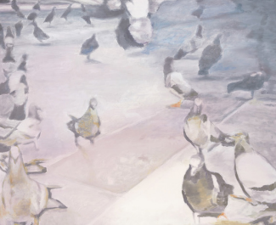
Luc Tuymans, Pigeons, 2001 (watercolour on canvas) Image courtesy of Bridgeman Images.

Gouache
Gouache is an opaque water-based paint, sometimes used for solid areas of colour in mixed media paintings or if body colour is needed in watercolour painting. It is a useful medium for designers and illustrators who can use it to block small areas of solid colour in finely detailed work.
As the paint has to be applied more thickly than watercolour, it needs to be more soluble and have greater flexibility. More glycerine is added to the mix to make this possible and chalk is added to extend the opacity of the pigments. Like watercolour, gouache can be diluted to make transparent washes but these will tend to be less brilliant in effect than watercolour washes.

Tempera
Tempera was widely in use as a painting medium in Egypt, India and throughout Europe from the first century AD through the Middle Ages into the Renaissance. It was used for all European panel paintings until the development of oil paints in the fifteenth century. Tempera painting has undergone periodic revivals, most notably at the hands of William Blake, the Pre Raphaelites and the Surrealist painter Giorgio De Chirico.
Tempera is a fast-drying and permanent painting medium. It consists of an emulsion derived from mixing ground pigments into a water-soluble glutinous substance. Traditionally, egg yolk was used for this purpose but glue, honey and plant gums are also used.
Tempera has to be applied in thin layers and its effects are built gradually with transparent or semi-transparent layers. Once applied, the colours are permanent and the paint surface is smooth, flat and very strong.

Oil paint
Oil paints are made of pigments that are finely ground into drying oils. The oils oxidise in the air and form solid skins in which the colour is evenly distributed. The oil most often used is fast drying or semi-drying linseed oil made from the seeds of flax.
Drying oil was used as a painting medium as far back as the Middle Ages. However, the Flemish van Eyck brothers, especially Jan van Eyck, working in the early fifteenth century, are widely regarded as the founders of oil painting as we know it today. Initially, the medium was more popular in northern Europe but in the 15th century, it gained ascendancy amongst Venetian painters. The flexibility and dazzling effects of oil painting were at the heart of the creative explosion of the Renaissance. By the early sixteenth century, oil was the most popular medium for easel painting throughout Europe and has remained so until very recent times.
The depth and range of oil colours are unparalleled, and the great benefit to the artist is that the appearance of the colour, once applied, remains the same and will not fade or alter after drying (with exceptions that will be explored later). What you see when you paint with oils is what you will get, unlike the alterations that can occur with water-based paints. In general, acrylic colours darken once dry, while watercolour paints tend to dry lighter.
Oil paint handles easily and is extremely versatile, lending itself to a multiplicity of effects. It can be used with different techniques to produce a wide range of textures and finishes. Oil paint can be applied to form a smooth and glassy surface – an illusionist’s window into other worlds. It can also be used to make a rough and rugged – almost sculpted – surface. It can be laid down in transparent layers, or worked straight from the tube or made thicker with additives for heavy impasto effects.
Using oil paints can be daunting as the properties of the paints are complex. The possible uses of mediums, diluents and varnishes are seemingly endless, but while you can modify, adapt and change you can also just use paint from the tube and dilute it with turpentine or white spirit. You can work on a painting while the paint is still wet, or alter it once it has dried.
A great advantage of oil paint – but also sometimes an inconvenience – is its slow drying time. You can work on a painting over several days while the paint is still wet, blending and merging colours or reworking certain areas altogether. Drying time will vary according to season, weather and temperature. It will also vary according to how thick the layers of paint are. Most manufactured oil colours take between 2 and 14 days to dry. The pigments themselves vary in drying times.
The drying time of different colours varies because each pigment requires a different volume of oil to give it a workable consistency. Colours that have high oil absorption shouldn’t generally be used under colours with low absorption as the top layer of paint will dry before the flexible oily layers underneath. This is what artists are referring to when they talk about ‘fat over lean’. If the top (lean) layer dries over the lower (fat) layers then cracking may occur as the surface paint shrinks. If turpentine is added to lower layers of paint, this will allow them to dry faster.
Many oil colours have drying agents in them (especially cheaper quality paints), so there can be no hard and fast rules about which colours will cause a problem, but if you use paint straight from the tube, you’ll need to make sure that the upper layers of paint won’t dry before the lower layers.

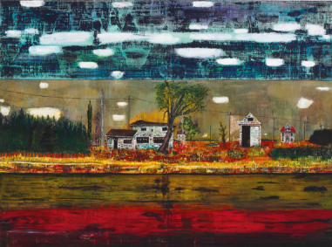
Peter Doig, Road House, 1991 (oil on canvas) Image courtesy of Bridgeman Images.

Diluents
Several essential oils are used by artists to dilute oil paint, but the most commonly used are turpentine (or ‘turps’) and spike lavender oil. Turpentine is an essential oil distilled from pine trees. It is a volatile and toxic oil so needs to be used with care. It is used to thin oil colour or as a solvent to make varnishes. Spike lavender oil is less volatile than turpentine and can provide an alternative for artists who cannot tolerate the smell of turpentine.
White spirit can be used to dilute oil paint, but it is cruder in effect and should be used with caution. There are white spirits produced specifically for artists which are purer in content. White spirit is mainly used for diluting varnishes and for cleaning brushes and pallets. Some people prefer to clean brushes with vegetable oils so that the bristles retain their pliability. Used alone to dilute paint (i.e. without oil), turpentine or white spirit can create a flattening effect and loss of colour intensity. This is sometimes described as ‘sinking’. If this happens, consider using varnish to restore the richness and intensity of colour once the painting has dried.

Varnish
Gloss or matte varnish, applied to a painting once dry, will bring back colour that may have sunk through the use of turpentine. Apply varnish in a dust-free environment using a special soft brush. Apply thinly and evenly using broad horizontal brush strokes, taking care to ensure that ridges of fluid don’t develop then run down. Also, check to ensure that bubbles don’t form by re-brushing while wet.
Most manufacturers suggest that you wait six months for a painting to dry out and settle completely before varnishing. This isn’t necessary for paintings that have quite thin layers of paint, but for heavier impasto layers it is wise to wait longer. As paint dries, dull areas that may need varnish start to become evident, but its worth waiting for some time before deciding what further work is necessary.

Using oils safely
Some artist quality pigments are poisonous. The most commonly used are the Cadmiums (Yellow, Red and Orange) and Cobalt and Cerulean Blues. Certain lead-based whites (such as Flake White) have largely been replaced by Titanium and Zinc White, which contain less lead and are less toxic. Many of the more toxic colours (containing substances such as arsenic, mercury and copper) are no longer in use.
Check the labels on your paints and keep them well away from young children and pets. Common sense and careful cleaning (especially under fingernails) should make using oil paints themselves quite safe. Be particularly careful if you use spray-painting techniques, though, because it’s possible to inhale fine droplets of toxic pigment and solvent.
The main health and safety consideration for oil paint users is the danger associated with solvents. Turpentine and white spirit are both highly flammable. These volatile fluids give off fumes that should not be inhaled and they require careful disposal. Ensure good ventilation when using thinners and be aware of fumes generated by clean-up rags. If you use white spirit to clean your skin, remove this as fast as possible; it’s advisable to use rubber gloves or barrier cream when cleaning up.

Research Task: In the Studio Videos
Access The Museum of Modern Art’s In the Studio playlist of online videos by artist and conservator Corey D'Augustine, to learn about the materials and techniques of post-war abstract painters.

Supports and Surfaces
Most surfaces are suitable for painting with a range of techniques. Acrylic paint can be applied directly onto bare canvas as it forms a bonded skin upon which other layers of paint can then be built. If you wish, you can prime bare canvas by applying acrylic primer with a decorator’s brush or by coating it using a plastic squeegee. An absorbent surface can be sealed with a diluted acrylic gloss medium before you apply paint.
A wide range of support surfaces can be used, such as canvas or paper or rigid surfaces such as wood panels or boards. Hardboard makes a useful and cheap support for oil paint and you can use both sides (smooth and rough), depending on the effects you want to create.
Pads of oil painting paper come in various sizes. These are relatively cheap to buy and provide excellent support if you’re a beginner. You can also buy prepared boards in many different sizes.
If you wish to save money or make cheaper supports for experiments and exercises, you can use any board or heavy paper as long as you seal the surface with a primer. Off-cuts of plywood, bits of board or cardboard can also be used.
There are various kinds of canvas materials: these include flax, hessian, artist’s linen, calico and variously graded cotton duck. Canvas is favoured as a support for both oil and acrylic paint, as the surface of the fabric catches pigment and allows colours to be caught on the outer surfaces of the weave, allowing the colour beneath to show through. The give of the surface works with the action of the brush and allows for a delicacy of effect that rigid supports cannot accommodate. The movement of the canvas under pressure from the brush can create subtle variations in the application of paint.
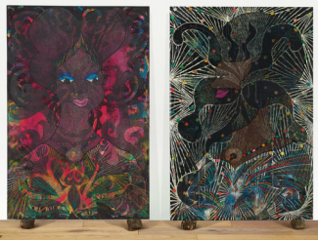
Gesso is a traditional ground for oil paint and can be used to create textures underneath the paint, allowing for interesting relief effects. Gesso is absorbent so should have a coat of primer applied over it if it’s to be used with oils.
Chris Ofili, Untitled Diptych, 1999 (acrylic, oil, phosphorescent paint, printed paper, paper collage, glitter, polyester resin, map pins and elephant dung on canvas) Image courtesy of Bridgeman Images.

Brushes
There are many good synthetic brushes available on the market specifically for use with acrylic paint. For some work, a set of decorator’s brushes will be useful. Almost any tool can be used to create a wide variety of effects, so keep an open mind.
The brushes most commonly used for oil paints are made of hog bristle, which holds and spreads the paint and is able to withstand the heavyweight of the paint. Bristle brushes come in a multitude of sizes and shapes; these are generally categorised as round, filbert and flat. Start with a range of small, medium and large brushes. You may find that you have quite a lot of brushes in use all at once as the task of cleaning each brush with every change of colour is rather arduous. Oil colours become polluted very easily, so you need to build up a collection to use.
It’s a false economy to buy cheap brushes. Bargain packs are often inferior in quality and it can be disheartening – and time-wasting – to have to pick up stray bristles that have been shed onto your painting. Many brushes suitable for oil paint can also be used with acrylic paints.

Cleaning brushes
White spirit is cheap and can be used for cleaning brushes. First, try to squeeze all the paint onto the palette or some absorbent paper or rag. Work as much paint as you can out of the brush and then, if you’re going to work again the next day, put the dirty brush into a jar of white spirit until you can clean up properly. Use rags dampened with white spirit to wipe your brush carefully.
Cheap household detergent washing-up liquid is very useful if you rub the brushes into this undiluted. A clump of painting material will come away which is then soluble in water. Vegetable oils can help to clean brushes and may help to restore dried-out brushes.
Take great care when disposing of white spirit, which is dangerous to the marine environment. One way to dispose of it is to allow sediment to form in your jar of cleaning white spirit. Tip-off the clear top layer into a new jar and dispose of the jar with dried sediment separately. This way, you can recycle the white spirit that you’ve used to clean your brushes and avoid tipping this dangerous substance down the drain.

Palettes
You can use almost anything as a palette for acrylics. As the paints dry fast and set hard, paper palettes can be a good idea – or the disposable plastic trays that come with foodstuffs like chocolate and cakes. If you have a special plastic palette, make sure that you keep it clean so that paint doesn’t set hard on it, forming a plastic layer. Be careful how much paint you put out each time, as it will dry hard and rapidly become unusable. A damp rag placed over your paints can keep it moist for another day, but this doesn’t always work. You’ll need to wash your brushes continuously so have an ample supply of water to hand in several containers.
The traditional palette for all oil paints is kidney-shaped with a hole cut in it for the thumb. These are often made from mahogany or mahogany plywood but buy one in a paler wood if you can. Unless you’re used to it, it’s harder to read colours on a dark surface so you’ll find a white palette easier to use. Off-cuts of white or pale formica make excellent palettes – or try glass with white paper underneath. There are also tear-off paper palettes, which saves cleaning up after use. These are light and ideal for outdoor use and can also be used for acrylic paints.
Painting knives are a valuable tool, particularly for oil paint. They can be used as a cleaning tool to scrape paint from the palette but there’s also a wide range of sizes and shapes that can be used for the application of paint straight from the tube for heavily textured effects. It is worth buying at least one modestly sized palette knife to experiment with working in impasto techniques. You can build your collection as you become more experienced.

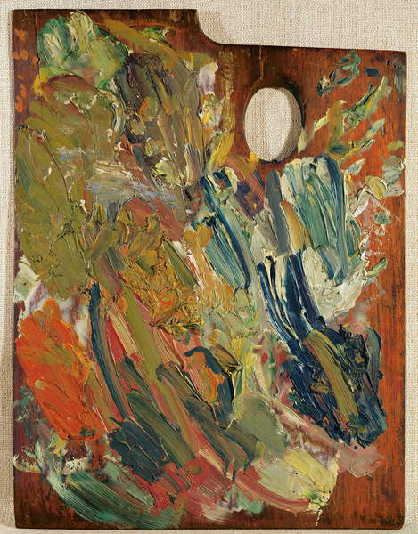
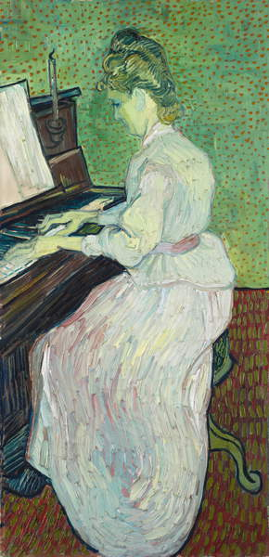
[Left] Vincent van Gogh, Marguerite Gachet at the Piano, 1890 (oil on canvas) Image courtesy of Bridgeman Images. [Right] Palette with which van Gogh painted Marguerite Gachet at the Piano, 1890, Image courtesy of Bridgman Images.

Other useful items
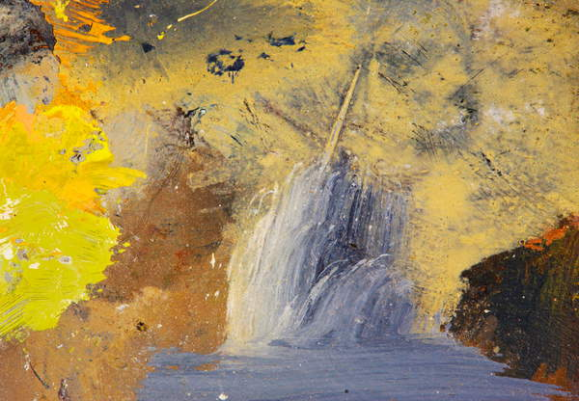
Over time you may collect a wide range of painting materials, mediums and tools. For this course, you can begin with a limited and basic set, a brush, a few colours, some paper. As you become more experienced you’ll be able to identify which items you need most. Alongside the key items mentioned, small jars for water and brush cleaning, tissues and newsprint, spare rough paper, rags, saucers and newspaper can be very useful within your workspace.
Accidental art, Composition taken from smeared oil paints on an artist's palette (photo) Image courtesy of Bridgeman Images.

Exercise 1: Basic paint application
Whether you choose to work in oil or acrylic paint, it’s important to gain some practice in handling your chosen medium and to learn some basic techniques.
The exercises in this course can be undertaken using either medium. If you have both kinds of paint available, read through the exercises in each project and decide which kind of paint you’ll use for each of them.
The possibilities of what can be done with any kind of paint are almost endless and you’ll need to find out for yourself which techniques best meet your particular creative needs. In this first exercise you’ll be exploring a variety of ways of applying paint and developing your confidence in handling paint. You’ll also gain a sense of the possibilities that you can explore later.
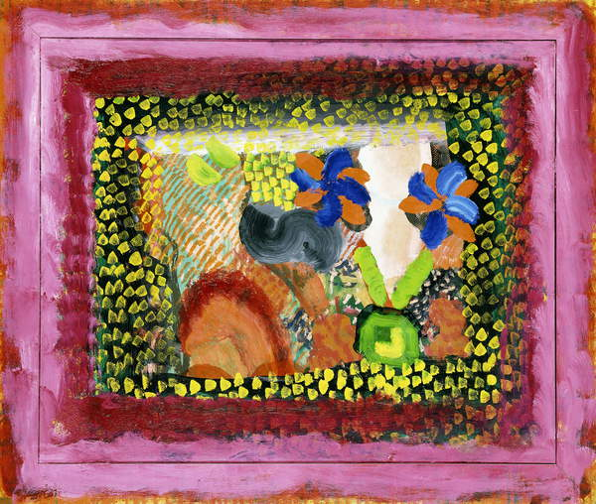
As you work through the exercises, document your working process and make notes in your learning log about how your chosen paint and colours behave. From the outset, you should be developing ideas for further projects of your own in the future.
Howard Hodgkin, Mr. + Mrs. James Kirkman, 1980-84 (oil on masonite) Image courtesy of Bridgeman Images.

Getting to know your brushes
Start by experimenting and exploring the range of marks and shapes that can be made with your brushes. Make various marks with brushes of different sizes, using flats, rounds and/or filberts.
Then, from memory, paint a small and simple landscape (about A4). Use large brushes so you won’t be distracted by the urge to include detail; instead, concentrate on the possibilities and patterns made by the brush marks.
Experiment with using the side of the brush as well as the flat and the tip. You’ll find that you can make surprisingly fine lines with the side of a brush. You can also use colour shapers, which are an excellent alternative to brushes.

Tip: Applying paint without brushes
Painting knives have been used for many centuries, usually in conjunction with brushes, but you can also complete whole paintings with just knives, which are sold in many sizes and shapes. If you don’t have one, use an ordinary palette knife well loaded with paint for your initial experiments.
Also try applying paint using old plastic credit cards, set squares or protractors, pieces of cardboard windscreen scrapers and plastic plastering tools. You can apply paint quite thinly with these and lay one colour over another so that the first layer remains visible. Don’t worry about creating a painting – just enjoy experimenting.
Try applying paint with sponges, rags, toothbrushes and your fingers. Sponges and toothbrushes are good for texture effects and can be built up in layers or laid over flat colour. Rags or fingers are useful for blending one colour into another or wiping paint across the surface.

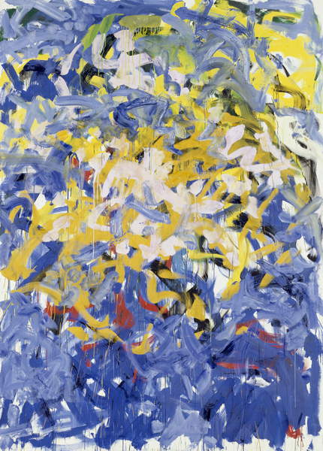
Joan Mitchell, Before, Again II, 1985 (oil on canvas) Image courtesy of Bridgeman Images.

Transparent and opaque
Continue by exploring ways of both applying and mixing paint. Controlling gradual fading or blending of colours is a very important skill in painting and it can be done in a variety of ways. Both oil and acrylic paint can be diluted to make a transparent or semi-transparent layer or glaze. A thin glaze of diluted colour over a reflective white ground can give a painting a luminous quality that’s not matched by mixing that same colour with white.
For oil paint, you’ll need a large brush and a pad of treated oil painting paper. You’ll also need turps in a small container, a jar of white spirit and a palette or an old saucer.
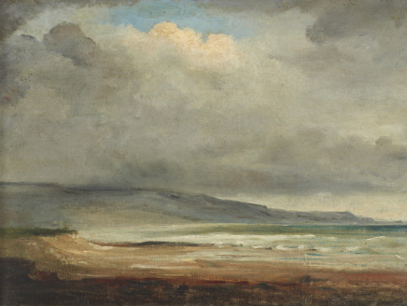
For acrylics, work on special papers, watercolour paper or stretched cartridge paper. (Stretch a sheet of cartridge paper dampened with a sponge over a board and allow it to dry slowly; this gives a smooth surface to work on.) You’ll also find it useful to have some scraps of paper to try out your colour mixes.
John Constable, Rain Clouds, Weymouth Bay, Dorset, (1776-1837) Image courtesy of Bridgeman Images.

Tonally graded wash
- Set up some paper lengthways. (This is called portrait format, as opposed to landscape).
- Look through your colours and choose either a strong red (such as Cadmium Red) or Ultramarine. Put a small amount of pigment on your palette or saucer and work in water or turps until you have a strong but fluid mix of the colour.
- Load a medium-wide brush and work from the top to the bottom of the sheet with increasingly dilute mixes of the colour until, at the bottom of your sheet, you have a very pale wash, almost faded out to white.
Practise this several times until you have a satisfactory progression from deep tones through to the very palest tones. Try to avoid the paint running by controlling the load on the brush and the flow of paint across the paper. Choose one or two sheets that have the most steadily graded wash and put aside one of these to dry.
- Now find another colour that is close to the original in the spectrum. If you chose Cadmium Red you could make this either orange or crimson. If you choose Ultramarine either a violet, turquoise or Viridian will be suitable. Make a dilute mix of the second colour and paint graded washes on at least two more sheets. Again, keep a sheet aside to dry in readiness for the next exercise.
- Next, working wet-in-wet, paint a graded wash onto one of the sheets that have the first colour. Keep the intense tone of the new colour at the pale end of the first colour and allow the colours to merge in the centre. Try this out so that you have several sheets of merged washes. It may help you to think of the gradual merging of colours in a sunrise or sunset where the horizon may be a scarlet or crimson red that fades up through purples to blues.

Overlaying washes
Using dried paper, make up the same colour mixes only this time paint the second colour over the dried wash that you set aside. Notice any differences in the way the paint and colour behaves and make notes in your learning log. For example:
- Does this method give you greater control?
- Have the colours merged in the same way?
- How could you employ these techniques of building coloured glazes?
Now that you’ve worked on single colour washes, wet-in-wet blended washes and overlaid glazes, practise these different ways of mixing transparent colour using a range of your pigments and note down the mixes that work well. Are there colours that are hard to blend?
You’ll have noticed how a bright blue cloudless sky will appear a deep ultramarine or cobalt blue above your head but fade away in the distance, appearing almost white on the horizon. The mixing and merging of a limited colour range have been explored by many artists and the effect of building layers of transparent and opaque paints can create a sense of different picture planes.

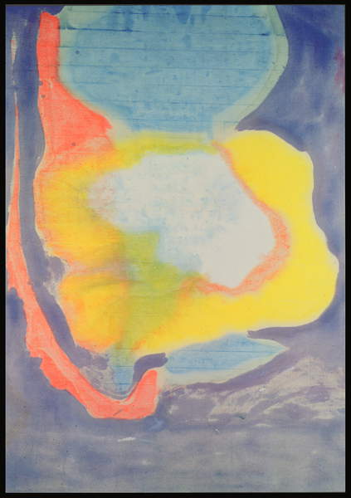
Helen Frankenthaler, April, 1963 (acrylic) Image courtesy of Bridgeman Images.

Opaque colour mixing
Some pigments have greater opacity than others without the addition of white and some can be laid on thickly to cover layers underneath, but white is essential for building body colour and is the vital ingredient for most opaque painting techniques. In this exercise, you’ll paint graded tones by mixing them in white.
Look carefully at your tonal mixes and put some white on your palette. Choose at least three of the washes you’ve painted (including the single colour ones) and attempt to recreate exactly the same colour, shade and tone of each of these in turn. This time, though, you’ll be mixing colours by adding in white, making the paints opaque.
Over-painting with acrylic works well because it dries so quickly. However, subtle, smooth colour blending is harder to achieve and that is the aim of this task. You’ll have to work fast at blending the graded tones of each colour by adding more white progressively or you could go from light to dark. Acrylic paints tend to dry darker than when they are applied so this exercise will help you to see how they behave.
If you’re working with oil paints, you should be able to blend the colours with ease. One way to blend colours is to lay out broad bands of colours to be mixed and gradually feather the tones across each other so that they blend smoothly and evenly.
When you’ve completed this, compare the effects of the transparent colour mixes (from previous attempts) and the opaque ones. Think about ways in which both methods could work together. Make notes in your learning log.

Monochrome studies
Now, you’ll explore two approaches to the same subject, one in which the transparent qualities of the paint provide the dominant effect and the other which exploits the opacity of the paint.
You could choose a range of subjects for this exercise, but the subject suggested is the outline of a winter tree seen against the sky, as this can be made as simple or complex as you wish and it has positive and negative shapes. If possible, work from an observational drawing but an imaginary tree will do or one loosely copied from a photograph.
- Draw the main outline of a tree, including the trunk and the main branches, and then roughly sketch in the diminishing outer branches and twigs.
- Prepare two sheets of paper (at least A3) or two boards. Prepare one of these with a dark coloured wash (you could mix this from Prussian Blue or Ultramarine and Payne’s Grey, Indigo, a dark earth colour mixed with blue or dark and dirty green). Prepare another sheet with a light grey ground either mixed opaquely or by using a wash. If you’re using oil paints, spread the colour thinly so that it will dry in a day or so.
- Now use charcoal to copy the image of your tree onto your two prepared papers or boards. Lightly dust the charcoal off so that a faint image can be seen. Working on the light ground first, use a fine hair brush to outline the positive shapes of the trunk and branches using the same colour mixture that you used for the dark ground. Fill the trunk and main branches with a dense, solid mix of dark colours. You could fade this colour out to suggest the finer outer twigs and branches.
- Next, start to work on the dark washed ground. This time build up the form and outline of the tree by painting in the negative shapes between the main branches, small branches and twigs. Mix up a light grey and apply this to the shapes formed by branches, trunk and the ground so that you gradually build up the form of the tree. Modulate this grey as you move away from the trunk towards the outer branches. Twigs can appear from a distance in a halftone.
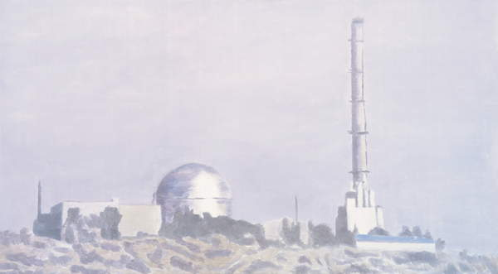
When you’ve finished both studies, assess the strengths and limitations of each approach. Note down how you think you could exploit these effects again. Both transparent and opaque methods are often used side by side in the same painting.
Luc Tuymans, Nuclear Plant, 2006 (oil on canvas) Image courtesy of Bridgeman Images.

Working on different coloured grounds
At this stage of the exercise, you’ll consider how working on a dark ground can shift your perception of what you’re looking at. When we look at a painting, there can all too often be a tendency to focus on individual objects rather than looking at the overall arrangement of shapes, tones and colours that are the essence of painting. When you’re working on observational studies, for example, it’s important to be aware of the design and compositional interest of negative shapes as well as the outline and form of the main subject.
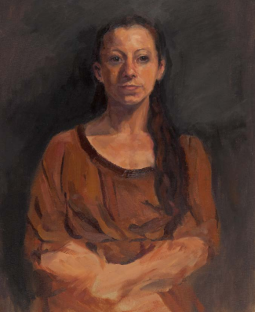
We’re accustomed to thinking of painting supports as white spaces onto which we make our marks. However, the use of white grounds is relatively new. Before the nineteenth century, it was customary for painters to work on coloured grounds. A white ground was exploited by the Impressionists who used the reflective white of the canvas to hold the brilliance and dazzle of the pure colours they used. As you’ve seen, white can illuminate transparent layers of thinly applied paint; it can also increase the impact of individual colours if the ground shows through between them.
Roda Fisher, Image courtesy of OCA student.
This part of the exercise aims to help you become aware of your options as a painter by giving you the opportunity to attempt tonal studies on both white and coloured grounds. Once you’re aware of the effects that a different ground can help create, you’ll be able to exploit this to create particular effects in your own work. If you want an area of a particular painting to retain a certain brilliance of effect, for example, you could leave that part of the canvas white so that you can apply a transparent or semi-transparent layer of pure colour over it. You may then decide to apply a coloured ground elsewhere in the picture.
Painting a mid-toned ground of uniform colour is an excellent way of establishing a tonal range, as it forms a midway point between the lightest and the darkest tones in a picture. Colours laid on to it can then be assessed easily for their tonal values.
Explore making a tonal study on a coloured ground. You’ll need to prepare this in advance to allow for drying time, particularly if you want to use an oil-based ground. For this reason, you’ll find it easier to use acrylic-based ground, even if you intend to paint in oils.

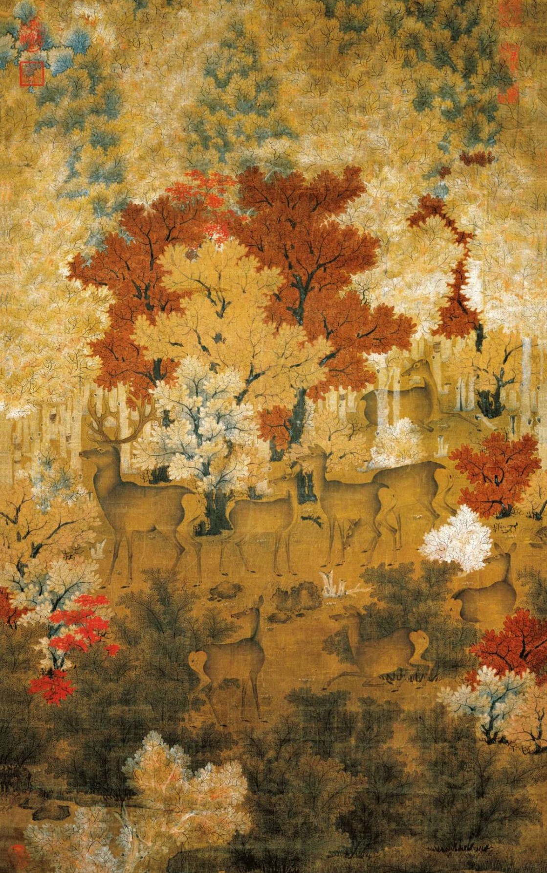
Painting of maple and deer of Liao dynasty, stored in Taiwan's National Palace Museum. Image courtesy of public domain.

Research Task 2: Colour Theory
Understanding something of how humans perceive colour has been at the heart of many artists’ endeavours. Various theories of colour have had a major influence on the experiments and creative aims of artists and movements.
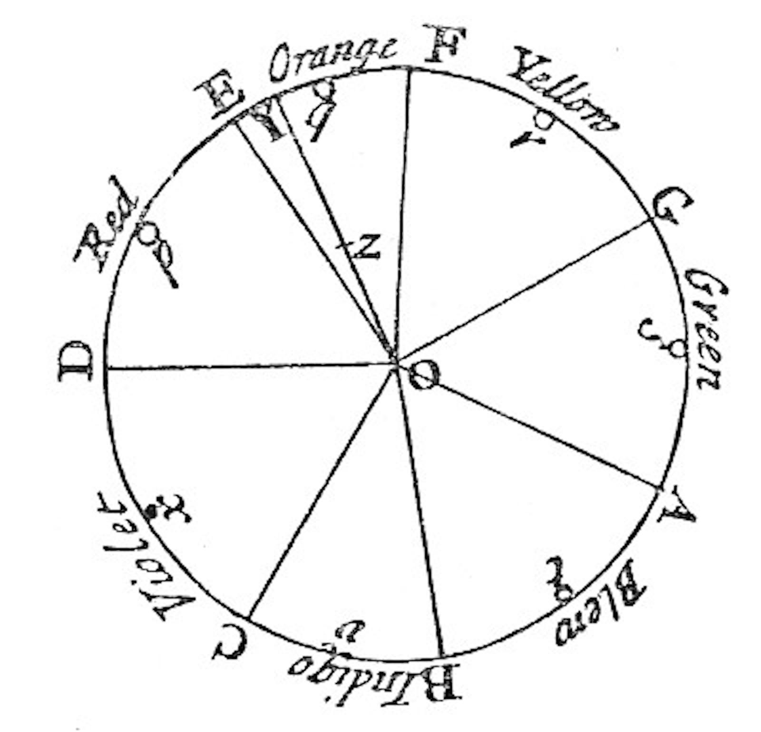
In the 1660s, Isaac Newton first demonstrated how light is responsible for colour. By projecting white light through a prism Newton was able to analyse the constituent colours of the rainbow. He went on to present a conceptual arrangement of colours around the circumference of a circle. This device allowed artists to understand how primary colours (red, yellow and blue) lie opposite their complementary colours on the spectrum (i.e. green, violet and orange). This became the colour wheel, a model for other later systems of understanding colour.
Newton's colour circle (1704) displayed seven colours. He declared that colours opposite each other had the strongest contrast and harmony.
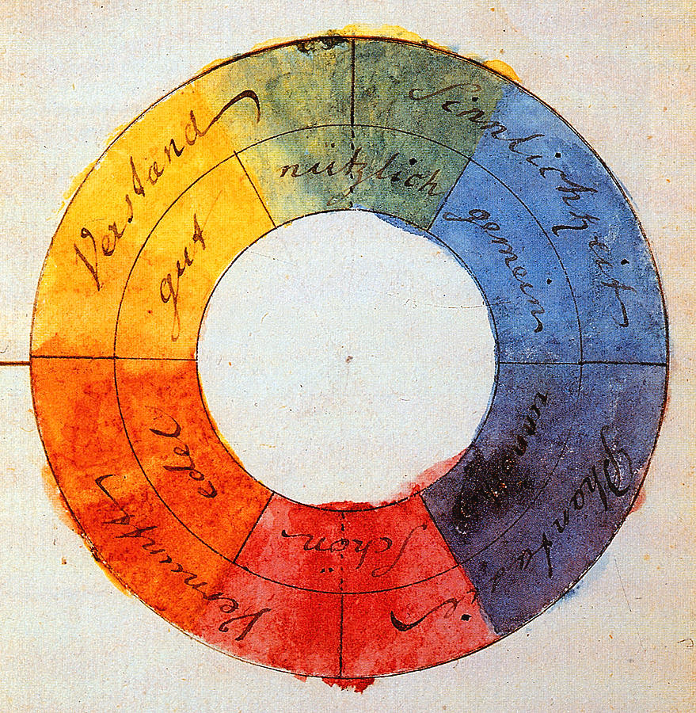
In 1810, the great German poet, playwright and scientist Johann Wolfgang von Goethe published a treatise on colour in which he explored how our sensations of colour are dictated by the mechanics of human vision and the ways that our brains process what we see. His theories strongly influenced Turner and the Pre-Raphaelites.
The colour wheel designed by Johann Wolfgang von Goethe (1810) was based on the idea that the primary colours yellow and blue, representing light and darkness, were in opposition to each other.
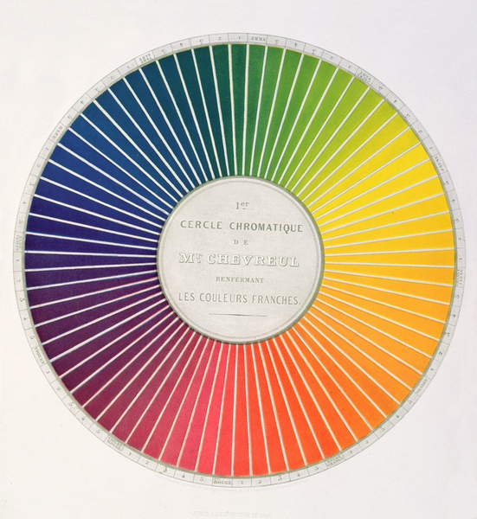
Eugene Chevreul, Circle demonstrating colour differences and contrasts, from a book, Expose d'un Moyen de definir et de nommer les couleurs, by, published in Paris by Firmin Didot in 1861 (colour litho) Image courtesy of Bridgeman Images.
The French colourist Michel-Eugene Chevreul published The Principles of Harmony and Contrast of Colours and their Application to the Arts in 1839 in France and 1854 in Britain. His colour theories had a great influence on the Impressionists and Neo-Impressionists and provided a basis for much of what has been taught in art schools since. Bauhaus teachers like the artist Paul Klee and Joseph Albers further developed his theories.
Later models used to describe the properties of colour were three-dimensional and the colour sphere shows how colours differ in hue, chroma and tone.
Spend time researching the colour theories of Chevreul and make notes on how particular artists have used Chevreul’s theories to expand the possibilities of painting.

Exercise 2: Understanding colour

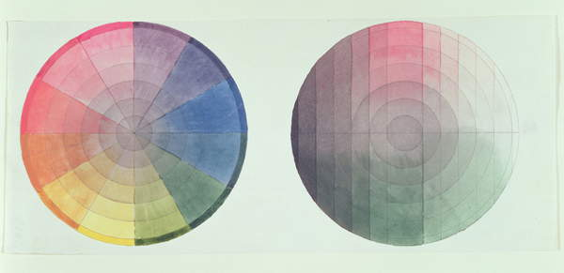
In this exercise, you’ll be developing your observational skills both by experimenting with colour and by exploring mixing and gradients. The main focus of this exercise is on developing your understanding of colour and how colour is perceived and how using coloured pigments creates effects that can help you interpret what you see.
Philipp Otto Runge, Two studies of the cross-section and longitudinal section of a Colour Globe, 1809 (pencil and w/c on paper) Image courtesy of Bridgeman Images.

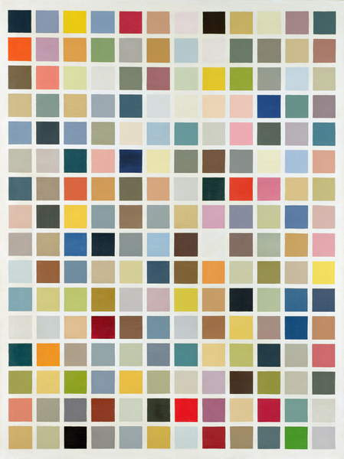
Gerhard Richter, 192 Colours, 1966 (gloss paint on canvas) Image courtesy of Bridgeman Images.

Now, explore putting some aspects of colour theory into practice. You’ll need:
- several large sheets of cartridge paper
- paper adhesive tape
- masking tape
- several art brushes in varying sizes
- palette knives
- coloured drawing media
- a wide selection of pigments in either oil, acrylic or gouache
- clean pots of either water or turpentine
- rags and palettes
- white emulsion paint and a tube of black acrylic (regardless of your choice of coloured media).
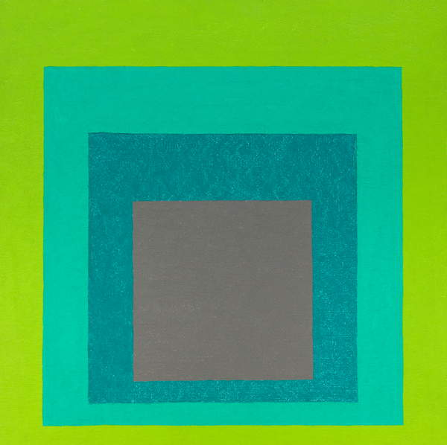
Before starting, stretch a dampened sheet of cartridge paper with a sponge, tape it to a board using brown tape ensuring it is even and allow it to dry slowly so that you have a smooth surface to work on.
Josef Albers, Homage to the square, 1958 (acrylic on masonite) Image courtesy of Bridgeman Images.

Mixing greys – Achromatic scale
- Start by mixing black pigment into white to create a tonal scale that is achromatic (i.e. that has no trace of colour). Work in a sequence of narrow lines of thoroughly mixed paint from white through the faintest of greys to darker greys until your darkest tone is straight from the black tube. Ensure that each is thoroughly mixed and that they are joined but not merged with each other.
- Work on this sequence several times until you can see a clear tonal progression.
- Study your scale and find the tone that is equidistant between black and white. This is a neutral grey. Now apply that grey mix to two small scraps of paper.
- Place these scraps by both the white end of the scale and the black end. What do you notice? Does the grey look the same?
- Use your neutral grey to prepare a ground for the following colour task. Mix black acrylic into some white emulsion to make neutral grey and paint this onto paper that you’ve stretched on a board.

Primary and secondary colour mixing
- First, identify your primary colours. Begin by laying small amounts of pigments onto your palette, arranging them in yellows, reds, blues, etc.
- Working on an area of your prepared grey ground, lay all of the yellows next to each other so that they touch but don’t mix. Notice the difference in hue (the way that one colour is distinguished from another), chroma (the intensity of colour) and tone (how light or dark it is). Arrange the yellows in different sequences and notice how different juxtapositions alter the appearance of the yellows. Make a note of which is the most intense yellow.
- Continue with this exercise using both your blues and reds. You’ll need to mix in a little white to see the hue of dark reds and blues properly as these pigments tend to be more transparent. Label your colours as you go.
- When you’ve identified your most intense yellow, blue and red – colours that appear to have no trace of the other primaries in their hue – you’ve got your primary colours to work with. You may have to mix Cadmium Red with crimson to eliminate any trace of yellow or adjust your blue or yellow by mixing in another pigment.
- On a grey ground, make a scale from yellow through to red by laying down narrow strips of colour next to each other in a carefully graded sequence. Next, make a scale from yellow to blue, then from red to blue.
- Make a note of how midway along the scale of yellow to red and yellow to blue, mixes of the secondary colours orange and green, respectively, are achieved. You’ll also notice how a dark murky mix between blue and red is not violet. Now try mixing other hues to achieve violets, such as Ultramarine (a red-blue), violet or magenta.
- Finally, make scales of colours using the same sequence as above but maintaining consistent tonal value by adding a little white. Repeat this exercise with yellow to red, yellow to blue and red to blue. Your blues and greens should have the same tonal values as yellow. When you work across the red to blue scale adding white to maintain consistent tonal values you’ll notice that midway between red and blue the pigment looks brownish grey.

Broken or tertiary colours
- Now make a scale between an orange-red and a green-blue. Try to maintain consistent tonal values across the scale by adding a little white, as you did in the previous task.
At the midpoint, add more white; the result should be grey. This is known as a broken or tertiary colour and this type of colour makes up the appearance of much of our world.
- Make a carefully graded scale between a pair of secondary colours: choose either orange to violet, green to orange or violet to green. Mix in white to maintain equal tones throughout (the lightest tone is orange). Once again, the middle mixes lose chroma to become broken/ tertiary colours
- Work carefully, noting on your sheet and in your learning log the colour mixes you’ve made and their effects.

Complementary colours
Complementary colours are on opposite sides of the colour spectrum. One way to learn about locating and mixing these colours is to make your own colour wheel.
- Draw a circle on an A4 sheet of paper and draw another circle inside this with at least 2 cm between them. You could use a compass for this or two plates.
- Divide up this wheel into twelve equal segments. Try to mix the colours from Chevreul’s colour circle or wheel beginning with primary red, red-orange, orange, orange-yellow, yellow and so on. You may need to work on several of these until you feel that you have satisfactory mixes.
- Next, consider the twelve colours from Chevreul’s colour circle and lay each colour next to its opposite or complementary on a grey ground. Try to match the darker tone to the lighter by adding white.
For example, the violet will need to be lightened to match the tone of yellow. Make mixtures of each pair of complementary colours. Make a note of the colours mixed and describe the resulting colour. This is another way of creating broken or tertiary colours.
- Look closely at the effect that complementary colours have on each other and try to explain this in your notes.

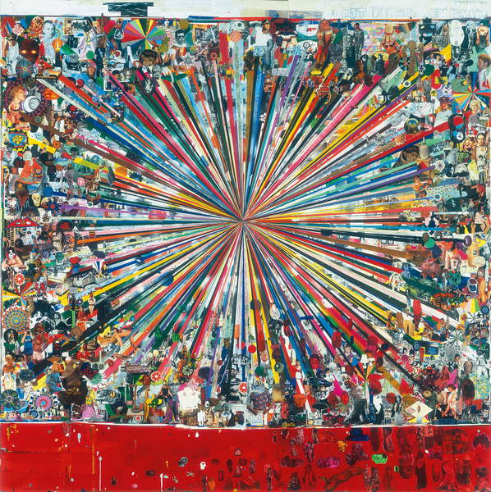
Tal R, Last Drawing Before Mars, 2003-2004 (printed paper collage, paper collage, acrylic, aluminium foil, wax crayon, fabric and glitter on paper mounted on board) Image courtesy of Bridgeman Images.

Exercise 3: Painting the colours you see
This exercise will help you to develop your observational and technical skills by focusing on a traditional genre of painting – the still life. The exercises in this project will give you a framework for your creative exploration of this genre – the choice of subject, palette of colours and handling of paint is yours.
Drawing is an essential element in painting and this exercise aims to develop your graphic and interpretive skills by bringing the discipline of observational drawing into painting. You’ll need a full range of colours in your chosen paint medium, all of your painting equipment to hand and several prepared supports to work on. You’ll also need a sketchbook with a range of drawing media.

Drawing in paint
Most painting involves some aspect of drawing and it’s important to maintain the critical and analytical approach of observational drawing in observational painting. Drawing in preparation for painting can often help to solve formal problems that are harder to solve with the fluid medium of colour.
- Look around your house for an arrangement of objects that just happens to be there. Don’t spend too long looking. It could be things that you keep on a shelf, table or window ledge or a corner of your kitchen. Don’t choose objects that are too complex in appearance, but choose things that you find interesting to look at. Make any minor adjustments that you need to create a simple still life arrangement from what happens to be there.
Work initially in your sketchbook with a pencil or some other drawing medium.
- Study your still life and notice the important linear aspects of what you see. Look at the hard lines and angles of the table, window ledge or wall. Notice the flowing lines of a draped fabric, if there is one. Look at how the outlines of objects and the spaces between them create particular relationships of line. Identify lines that define tonal areas. Look at how the shining surfaces of ceramic or glass reflect outline shapes and lines. You may be able to see lines of wood grain on a table or lines on a patterned cloth that can create a sense of dynamism and movement in your still life arrangement.
- Make a series of drawings that explore the linear qualities of your subject and choose one of these that strikes you as especially interesting or effective. Now go back to the subject and consider what format, scale and surface you want to work on for your painting.
- With a diluted and fairly neutral pigment, draw some of the main outlines you can see with some of your finer brushes (use a soft hare brush if you wish to create fine lines). When you’re satisfied with the placement of important lines, begin to work on colour, taking care to ensure that line retains its presence in your picture. You may decide to make stronger and more obvious outlines once most of your colour work is done. Some artists deliberately retain outlines around coloured shapes to locate them clearly or to create a sense of receding picture space.
The following optional tasks encourage you to combine your colour work and experience by painting in a combined still life colour study.
Choose one option below in the first instance. Of course, you’re free to attempt all three if you have time. Alternatively, you could come back to the exercise that you haven’t yet attempted later on in the course.

Option 1: Still life with natural objects
Assemble a group of natural objects. These could be highly-coloured objects such as fruit or vegetables (peppers make an excellent subject), more subtly coloured vegetables or highly structured objects that are almost monochrome such as shells, skulls, rock crystals or seed heads. If you choose to work with tertiary colours and subtle lines and tonal variations, you could include an element that is highly coloured such as a red fabric background or a brightly coloured piece of fruit such as an apple, orange or lemon. It’s best to choose simple forms rather than complex ones for this exercise; just two or three objects will give you enough subject matter.
Use your sketchbook to help you to locate an interesting point of view. You may wish to zoom in and lose the outline shapes of the subject to give greater compositional interest.
Notice where the light falls and its varying effects on the surfaces of objects. Consider how the lightest areas appear on a shiny reflective surface. Look also at the darkest areas of shade and analyse the colours that can be seen there. Half close your eyes to obtain an overall sense of the tonal values and assess where the lightest areas are. It’s important to keep on doing this when you’re painting or drawing almost any subject from life in order to ‘switch off’ compositional detail and colour and concentrate solely on tonal variation.
You may wish to work on small coloured studies first using coloured pencils, oil pastels or watercolours. Once again, decide on your format, scale, composition, light source and colour palette. Make notes as you go along.
Assess your finished painting carefully.
Make notes in your learning log on:
- how you’ve progressed from your first attempt at still life
- any problems that the natural objects presented
- your choices, working methods and finished painting
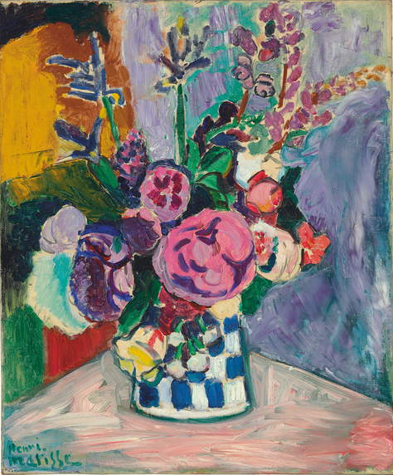
- what you’ve learned from this exercise.
Henri Matisse, Les Pivoines, 1907 (oil on canvas) Image courtesy of Bridgeman Images.

Option 2: Still life with man-made objects
Select some man-made objects (no more than four) that you can put together to create an interesting still life arrangement. Find objects that are linked by common use such as kitchen equipment, woodworking tools, your own painting kit or children’s toys. Look for interesting textures and forms that relate well to one another (such as jugs or teacups).
Arrange your objects, then spend some time working out the format (portrait, landscape, square) and composition of your study in your sketchbook.
Make a careful evaluation of tonal variation and sketch this using pencil or charcoal. Look at the reflective qualities of metal, glass and ceramics. Locate the lightest highlights and the progression through to the darkest tones. Try to match equal tonal areas in contrasting colours and make notes of this; for example, a blue jug may be tonally equal to a red mug.
Think in advance about how you could exploit the visual drama of tonal contrast or divide areas of colour in an interesting way (outlining negative shapes could help you here).
Before you start painting, decide whether you wish to work in broad areas of colour and tone thereby creating a flattening out effect in the painting or whether you’ll make the objects appear more solid by exploring all of the tonal values carefully and analytically.
Analyse colours within the shaded areas and try to recreate these colours as well as you can. Constantly reassess your colour management as a whole.
When you’ve completed your still life, look at it carefully and make notes in your learning log.
Comment on the following:
- your planning and working methods
- your choice of format/scale
- the composition
- colour interest
- your use of tonal contrast
- your paint handling
- what elements have particularly contributed to the success of this painting?
- which areas need further development and practice?

Option 3: Still life with complementary colours
Make a colour study of your still life arrangement using only a narrow range of colours. This will require great concentration and discipline in observation and interpretation of tone. Make the most of using colour in an inventive way.
Choose just two hues, one colour and its complementary and use white to lighten the tone. You can mix the complementary colours to create a range of broken colours. You could work towards a monochrome effect by losing the high chroma of the unmixed colours through mixing towards the greys and black that they can create together. Alternatively, you could exploit the juxtaposition of these colours in their brightest unmixed form. Remember that to create the strongest effect you should lift the tone of the darkest hue to match the lighter colour.
Use the full tonal range of each colour to provide tonal interest or make deeper tones from mixing the colours together. Experiment and see how the colours behave alongside each other or when mixed. If you’re not satisfied with your first attempt, make several studies.
Make notes in your learning log on the challenges of this exercise.

Exercise 4: Colour relationships
In this exercise, you’ll continue to explore colour relationships. As you’ve seen, colours are not fixed: the appearance of a hue constantly changes according to the light and its juxtaposition with other colours.
Simultaneous contrast is where the colour appears to change when seen against a different background.
Successive contrast refers to the fact that when you view a particular colour, you get an afterimage of its complementary colour. This optical effect lends greater intensity to both of the complementary colours present.
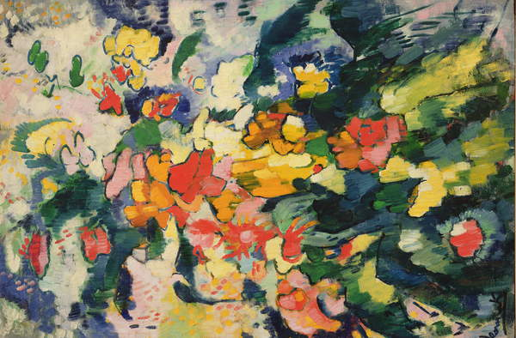
When two perfectly chosen complementary colours are placed side by side, they each appear more vivid and intense and a vibrating boundary between them creates a sensation of movement. These effects can be exploited to great effect in both abstract and representational painting.
Maurice de Vlaminck, Flowers (Symphony in Colours), 1907 (oil on canvas) Image courtesy of Bridgeman Images.

Exploring contrasts
- Choose any colour you like (colour A). Now mix a series of several colours that are close in the spectrum to colour A. Paint a series of small squares of colour A, surrounding it each time with one of the colours you’ve mixed.
Notice how the centre colour A alters each time in relation to its surrounding colour. When colours that are not opposite to each other on the spectrum (i.e. not complementary) are seen together, they have the effect of cancelling each other out.
- Now try mixing a colour and its complementary (i.e. the opposite colour on the colour wheel). Paint a small square of the brightest of this pair of colours. Now paint around this colour with a larger square of this colour’s complementary made equal tonally by the addition of white. What do you notice?
- Working either with the same or a different pair of complementary colours, paint a square frame in each colour side by side, leaving a square gap in the middle of each. Now paint a similar square frame of white underneath, again leaving a square gap in the middle.
- Mix a neutral grey or beige colour and fill each of the central squares with this colour. Take care not to let the colour in the centre mix with the surrounding colour.
Notice how the appearance of your neutral colour alters.
Make notes about the colours you’ve mixed and their effects on each other.
If you have time, experiment with these effects of enhancing or modifying colour intensity in a series of small paintings or just keep trying out different colour combinations, making notes as you go.
In the previous exercises, you’ve seen how complementary colours (as the name suggests) enhance each other so that they appear more vivid and intense when seen together. On the other hand, when colours that are close to each other on the spectrum are placed together they can have the effect of cancelling each other out. Tonal values are also perceived differently depending on the tonal values of adjacent areas.

Tip: Gerhard Richter
Among the most recognized and influential artists working today, Gerhard Richter is difficult to classify because he simultaneously paints in a staggering variety of styles, veering freely from realism to abstraction. Abstractions, such as this one below, have constituted a large part of his production since the mid-1970s. Abstract Painting (750-1) is from a series that Richter created between 1988 and 1991.
Beginning with a ground of bright colours, such as red, yellow, blue, or green, he applied additional coats of pigment. He covered each thin layer of paint with a sheet of plastic that was pulled away to create a blend of overlapping colours, textures and shapes. Richter applied the paint quickly, but the process was time-consuming, allowing the artist the opportunity to evaluate and change each work as it evolved. Although this dense composition has no recognizable imagery, it conveys a sense of movement not unlike the experience of looking out of a car window at the landscape streaking past.
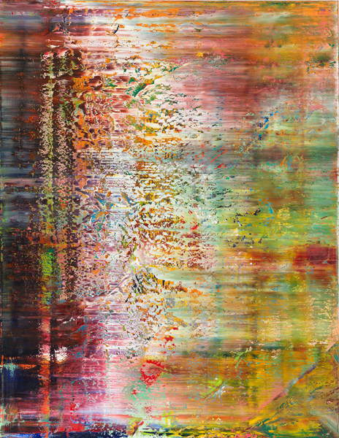
Gerhard Richter, Abstract Painting (750-1), 1991 (oil on canvas) Image courtesy of Bridgeman Images.

Research Task 3: Optical effects
Find or paint a large area of bright colour; this could be a bright red jumper, a piece of coloured paper or a square of painted pigment. Stare at it for 30 seconds. Now close your eyes and wait until an after-image appears. If you focus hard, a hazy shape should appear of the complementary colour (red will appear as green and so on).
Now paint an isolated square of your most vivid and intense pigment. Stare at this for 30 seconds. Now shift your gaze to a sheet of white paper. You may find it helpful to focus on a pencil dot on the sheet. Notice the appearance of an after-image. This is the complementary colour.
These effects are caused by the stimulation and exhaustion of colour receptors in the retina. By exhausting the receptors for red, for example, only the remaining combinations of colours that mix to produce blue-green are seen when you turn from looking at red to looking at white.
White light, as Newton showed, is made up of all the colours of the spectrum. The human eye has full-colour discrimination through the rod and cone cells. The rod cells in the retina distinguish light and dark, while the three types of cone cells respond to red, green and blue-violet which makes up all colours.
Optical effects have been exploited by many artists to create movement and depict the effects of light. The Impressionists, Post-Impressionists and Neo-Impressionists – in particular the Pointillists, Seurat and Signac – made full use of the new understanding of the nature of human perception.
The Neo-Impressionist painters’ Paul Signac and Georges Seurat developed a system of applying paint in tiny disconnected dots of pure colour onto a white ground in a technique called Pointillism. The idea was that colours would be mixed in the eye of the viewer by a process known as optical mixing.
Find out what you can about these artists’ aims and study their work to see how they achieved effects such as optical mixing. Look also at the work of Bridget Riley or the Op artists. Make notes in your learning log.
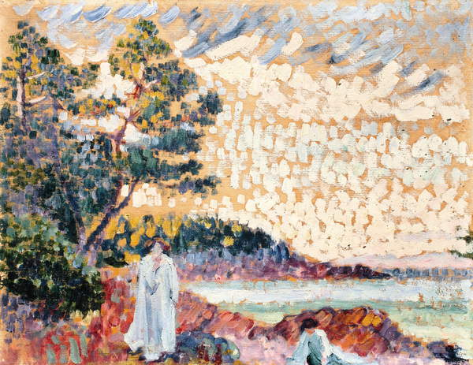
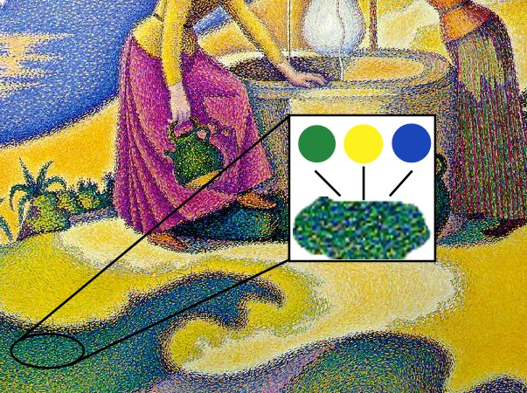
Paul Signac, Femmes au Puits, 1892, showing a detail with constituent colors. Musée d'Orsay, Paris (Pointillism).
Henri-Edmond Cross, Two Women in a Seascape, c.1900 (oil on paper on canvas) Image courtesy of Bridgeman Images.
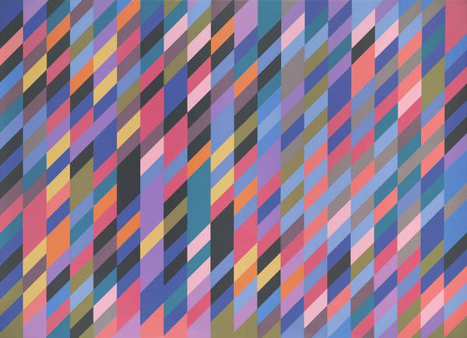
Bridget Riley, Shadow Rhythm, 1989 (oil on linen) Image courtesy of Bridgeman Images.

Colour accuracy
In some ways, there is no such thing as colour accuracy, as we all perceive colours differently and are drawn by taste, inclination and experience to notice and enjoy certain colours in certain combinations. But in this task, you should aim for objectivity in attempting to recreate as precisely as you can the colours as you see them. The main thing is to try to read colours carefully, noting the transition from light to dark tones of the same hue and where tonal values are equal in different colours.
- Start by choosing a subject, this could be another still life, or a landscape study, perhaps a view from a window.
Look at where the light falls and evaluate the relative tonal values of all that you see by looking at the subject through half-closed eyes. A tonal drawing using soft pencil or charcoal will help you in your analysis and you can refer to this when you start your painting. Look for an interesting juxtaposition of colours or the interplay of strong highlights.
- Try to simplify and not get too involved in detail. A window mount (viewfinder) will help you to select a small area of your subject to focus on. Another way to simplify is to select broad areas with interesting colour and tonal juxtaposition with shapes that are pictorially interesting. Work carefully to mix colours and shades of hues as precisely as you can.
- When you’ve finished your painting, stand well away from it and assess it against the colours of the subject itself. Does it stand out? Are certain colours too vivid or not bright enough? Is your painting lighter in tone or darker than the prevailing tones of the subject itself? Make notes in your learning log.

Colour to evoke mood
Next, paint your subject using colour in any way that you choose. Make decisions in advance about the range of colours that you will use. You’re aiming to create a mood or atmosphere in your use of colour and handling of paint.
You could, for example, heighten effects by exaggerating contrast or making certain hues brighter than they appear. Conversely, you could soften or mute colours for a gentler or even more sinister effect. You could aim to create a chilly and distant feel or a warm and intimate atmosphere.
While the subject may be prosaic, your handling of it need not be, you can explore the more expressive and subjective aspects of painting.
Set out your completed colour studies side by side and make notes in your learning log about the different effects you’ve been able to create using the same group of objects.

Tip: Fauvism
Fauvism is the name given to paintings produced by a group of artists from around 1905 to 1910, characterised by strong colours and intense brushwork. The fauvists were interested in the scientific colour theories developed in the nineteenth century – particularly those relating to complementary colours.
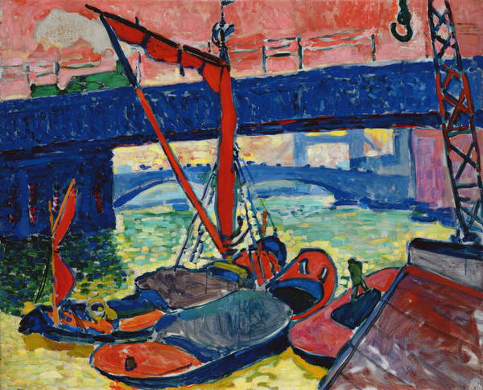
Andre Derain, Barges on the Thames, 1906 (oil on canvas) Image courtesy of Bridgeman Images.
The name les fauves (‘the wild beasts’) was coined by the critic Louis Vauxcelles when he saw the exhibition, the Salon d'Automne in Paris, in 1905. Paintings by Henri Matisse and André Derain were exhibited that were made after a summer spent working together in Collioure in the South of France and were made using bold, non-naturalistic colours and wild loose dabs of paint.
Fauvism was an early modernist art movement and one of the first styles to make a move towards abstraction, for many of the artists who adopted a fauvist approach it became a transitional stepping stone for future developments in their style.
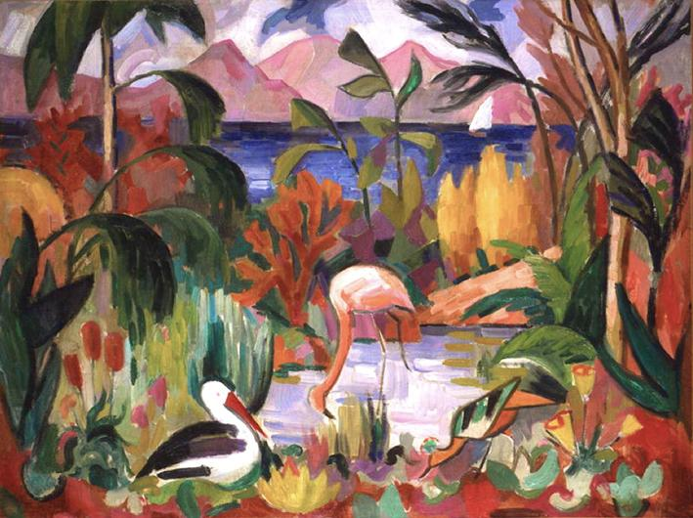
Georges Braque occasionally adopted a fauvist style and went on to develop cubism along with Pablo Picasso. Henri Matisse however continued to use the distinctive fauvist traits of bright emotive colours, simple shapes and painterly mark-making throughout his career.
Jean Metzinger, Paysage coloré aux oiseaux aquatiques, 1907, oil on canvas, 74 x 99 cm, Musée d’Art Moderne de la Ville de Paris.

Exercise 5: Personal palette
Your work for this final exercise allows you the freedom to expand your ideas in a self-directed and independent manner. It is recommended that you review all your work from the course to date and identify an aspect to develop further.
You can begin a new piece or you may want to develop one of the exercises that you’ve done previously.
Choose a subject to work with, your painting medium and decide on the format and scale for your work. Choose the support you’d like to use - paper, card, canvas or anything suitable to your needs. Work in either portrait or landscape format and choose a background colour if necessary. Seek to produce a work that highlights your understanding and knowledge of painting with colour.
Consider the following points as you begin to undertake this exercise:
- your viewpoint
- the direction of the light source
- highlights and shadow (tone)
- the relationship between foreground and the background
- the mood you wish to convey.
- mixing personal and unique colours.
Document your process and final outcome, and make notes in your learning log as you work.

Optional further research: Contemporary colour
This resource has touched the surface of painting with colour and you are encouraged to continue to explore and discover the myriad ways in which painters have used, and continue to use, colour creatively, technically and conceptually.
The following images have been selected to showcase the diverse application of colour and how it is applied in relation to divergent cultures, styles and histories. Review each painting and follow up with your own research, making notes in your learning log, and adding further contemporary artists you discover during the process.

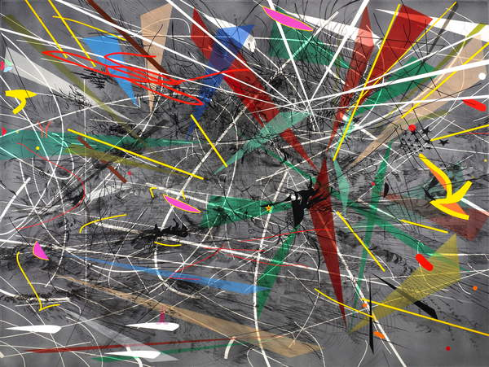
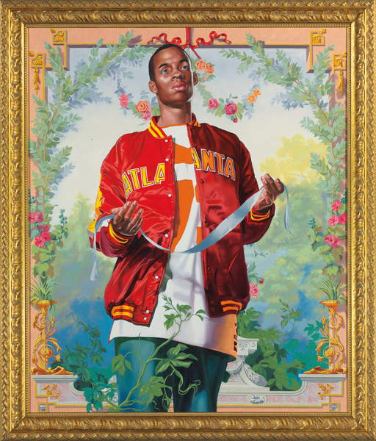
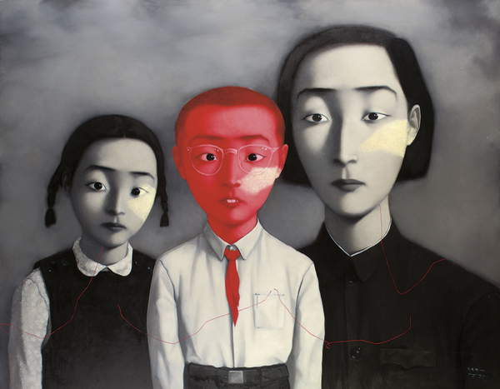
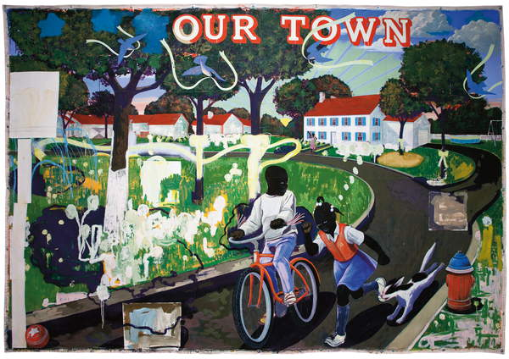
Kehinde Wiley, Passing/Posing From Coronation of the Virgin, 2005 (oil and enamel on canvas) Image courtesy of Bridgeman Images.
Julie Mehretu, Grey Space (distractor) 2006 (ink & acrylic on canvas) Image courtesy of Bridgeman Images.
Zhang Xiaogang, A Big Family Series, 1995 (oil on canvas) Image courtesy of Bridgeman Images.
Kerry James Marshall, Our Town, 1995 (acrylic and printed paper collage on canvas) Image courtesy of Bridgeman Images.
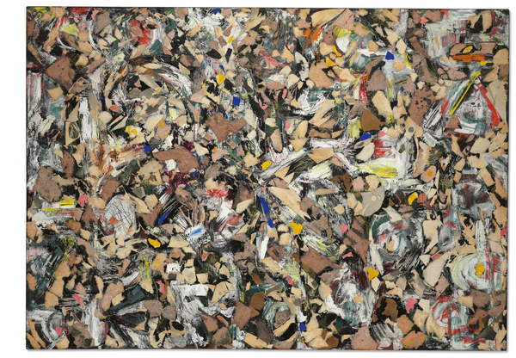
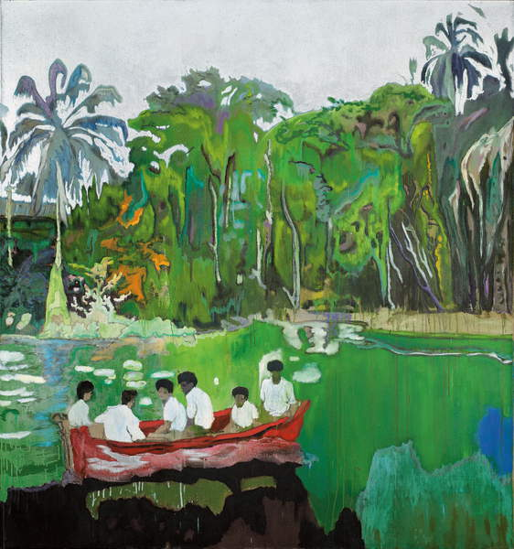
Peter Doig, Red Boat (Imaginary Boys), 2003-2004 (oil and metallic silver paint on canvas) Image courtesy of Bridgeman Images.
Lee Krasner, Shattered Light, 1954 (oil and paper collage on Masonite) Image courtesy of Bridgeman Images.

Exercise 6: Reflection
It may help you to write or record a video commentary (approx.. 300 words or 2min video) reflecting on your learning here and how this connects to broader themes in your work or ideas - what have you learnt about Painting with Colour so far? What do you find particularly engaging? Reflect on the skills you have acquired here and how you might apply them to your developing creative practice.

Supporting your skills
As you create work that responds to the exercises on this micro-course, you may want to ask questions from tutors or share your work with your peers to support your studies here. Please use the support spaces in the Skills Hub to receive specialist support responding to the specific skills you're developing.
When you are ready to apply the skills you have acquired here, please return to your creative department and unit that you're undertaking.

About the Skills Hub
The Skills Hub offers learning opportunities across a range of disciplines to help you develop your creative skills. If you would like to offer any feedback or make suggestions please use the Skills Hub forums on OCA Learn.
We hope you have found this resource useful. Sharing your experiences with fellow students can help inspire and motivate others, please use the online spaces to support each other.

